MICROSOFT COPILOT STUDIO

Table of Contents

WHAT IS COPILOT STUDIO? 2

WHY WAS COPILOT STUDIO CREATED? 2

COPILOT STUDIO BUILDER 3

HOW COPILOT WORKS 3

TOPIC IN COPILOT STUDIO 3

TYPES OF TOPICS 3

CREATING ENVIRONMENT 4

CREATE AN AGENT WITH COPILOT STUDIO 5

MANAGE *TOPICS* IN YOUR AGENT 9

TOPIC OVERVIEW 9

CREATING TOPIC 11

ADD A KNOWLEDGE SOURCE FOR GENERATIVE AI RESPONSES 21

PUBLISH YOUR AGENT 24

IMPORT DATAVERSE SOLUTION 26

Exercise 1 – Import solution: 27

BUILD AN INITIAL AGENT 30

Exercise 1 - Create agent 31

EXERCISE 2 - ADD GENERATIVE AI ANSWERS 32

# WHAT IS COPILOT STUDIO?

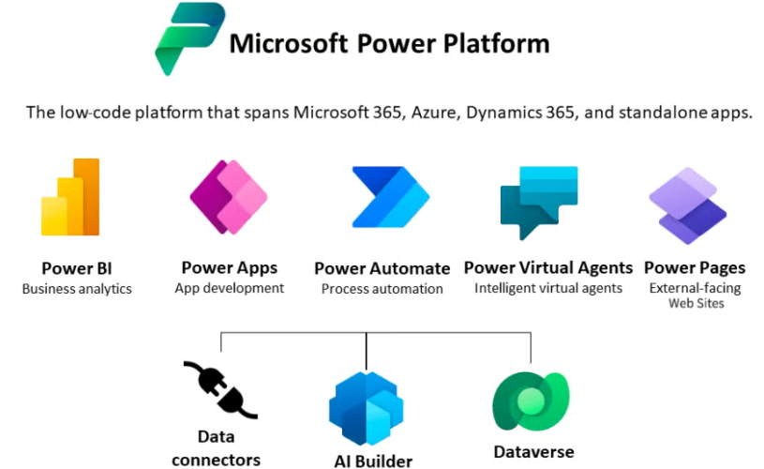

The **Microsoft Power Platform** is a suite of low-code/no-code tools designed to empower users—both technical and non-technical—to build apps, automate workflows, analyze data, and create virtual agents. It consists of four main components:

1. **Power BI** – for data visualization and business analytics.
2. **Power Apps** – for building custom applications with minimal coding.
3. **Power Automate** – for automating workflows across apps and services.
4. **Power Virtual Agents** – for creating intelligent chatbots without writing code.

|  |
| --- |
| **Copilot Studio extends Power Virtual Agents by integrating AI capabilities, allowing users to build and customize intelligent copilots.** |

**Microsoft Copilot Studio** is a tool within the Power Platform ecosystem that allows users to **customize and extend Microsoft Copilot experiences** or even **build their own copilots** (AI assistants) using natural language and low-code tools.

**HERE’S HOW IT CONNECTS TO THE POWER PLATFORM:**

* It **builds on Power Virtual Agents**, enhancing it with **generative AI** capabilities.
* It allows users to **integrate AI-powered copilots** into apps, websites, or workflows.
* It supports **data integration** with Microsoft Dataverse, Power Automate, and other Power Platform tools.
* It provides a **visual authoring canvas** to design conversations, integrate APIs, and manage AI behavior.

## WHY WAS COPILOT STUDIO CREATED?

The idea behind Copilot Studio is to **evolve traditional chatbots** into more powerful, intelligent, and flexible AI assistants by leveraging **generative AI**. Here's the core reasoning:

1. Traditional Chatbots Are Limited which has relied on rigid, predefined question-answer flows and require manual setup for every possible interaction.
2. On the other hand, copilot’s studio uses GPT-based generative AI to understand and respond to user queries dynamically. It can reference documents and knowledge bases to generate answers without predefined flows.
3. Copilots can trigger workflows and automations based on user input. Example use case: An **internal vacation assistant** for employees.
4. Users can ask questions like: “How many vacation days do I have?”, “When can I take vacation?”, “Who needs to approve my leave?”- Once ready, users can **submit vacation requests directly through the copilot**. Hence, the copilot collects necessary details and **automatically triggers a workflow** to process the request. This eliminates the need to redirect users to separate forms or apps.
5. **Build Once, Deploy Anywhere**: Create once and publish across Teams, websites, apps, social media, etc.
6. **Extensible:** Copilot can send HTTP requests to any application that has an API. and if an application doesn't have an API, we can create your own API for it.

# COPILOT STUDIO BUILDER

## HOW COPILOT WORKS

In **Microsoft Copilot Studio**, a **"Topic"** is a fundamental building block used to define how a copilot (chatbot) interacts with users.

## TOPIC IN COPILOT STUDIO

A **Topic** is a **conversation path** or **dialogue flow** that handles a specific user intent or question. It includes:

1. **Trigger phrases**: Words or phrases that start the topic (e.g., “I want to apply for leave”).
2. **Conversation nodes**: Steps that guide the conversation, such as asking questions, showing messages, or calling actions.
3. **Actions**: Optional steps that can trigger workflows, call APIs, or retrieve data.

### TYPES OF TOPICS

* **Prebuilt Topics**
  + Provided by Microsoft for common scenarios (e.g., greetings, help, end of conversation).
* **Custom Topics**
  + Created by users to handle specific business needs which are fully customizable with own trigger phrases and logic.
* **Generative AI Topics**
  + Use large language models to dynamically respond to user queries based on documents or knowledge sources.
  + No need to define every possible question.
* **Default Topics**
  + These are **prebuilt topics** provided by Microsoft to help us get started quickly.
  + They cover common conversational scenarios and can be **customized** to fit our needs.

**Examples:**

* **Greeting** – Welcomes the user when they start a conversation.
* **Goodbye** – Ends the conversation politely.
* **Help** – Helps or explains what the copilot can do.
* **Thank You** – Responds to user gratitude.
* **Escalate** – Transfers the conversation to a human agent if needed.
* **System Topics**
  + These are **built-in topics** that handle **core system-level interactions**. They are essential for the copilot’s functionality and are often **not editable**.

**🔹 Examples:**

* **Fallback** – Triggered when the copilot doesn’t understand the user’s input.
* **Authentication** – Manages user sign-in and access control.
* **Error Handling** – Responds to system or API errors.
* **Escalation Management** – Handles routing to human agents or support systems.

|  |  |  |
| --- | --- | --- |
| * **Example Topic: Vacation Request Assistant** * **Topic Name: *Vacation Request*** | **Trigger Phrases:**   * “I want to take a vacation” * “How do I apply for leave?” * “Request time off” * “Vacation form” | **Conversation Flow:**   1. **Message Node**: *“Sure, I can help you with your vacation request.”* 2. **Question Node**: *“What are the start and end dates of your vacation?”* → Captures: startDate, endDate 3. **Question Node**: *“What is the reason for your leave?”* → Captures: reason 4. **Action Node**: *Trigger a Power Automate flow* to submit the vacation request using the captured details. 5. **Message Node**: *“Your vacation request has been submitted. You’ll receive a confirmation shortly.”* |

## CREATING ENVIRONMENT

1. Open : <https://admin.powerplatform.microsoft.com/home> 🡪 Manage 🡪 New

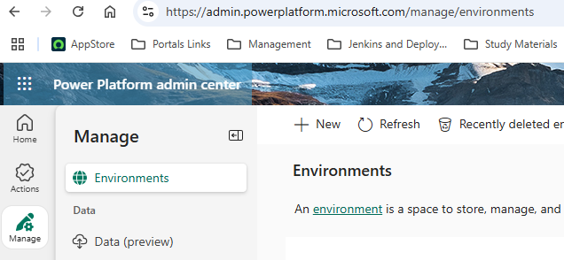

|  |  |
| --- | --- |
|  | 1. Select **+New** and create a new environment with the following settings:    * **Name**: *Enter the unique environment name provided in your lab environment*    * **Region**: *Choose the****default****region*    * **Get new features early**: No    * **Type**: Developer    * **Purpose**: Lab exercise    * **Add a Dataverse store**: Yes    * **Pay-as-you-go with Azure**: No    * **Add Dataverse options**:      + **Language**: English      + **Currency**: USD ($)      + **Deploy sample apps and data**: No 2. Wait until the state of your environment is **Ready** (you can use the **Refresh** button to update the display) 3. Navigate to <https://copilotstudio.microsoft.com/>  (sign in with your credentials if prompted). 4. When prompted, select the option to start a free trial. 5. Skip any welcome messages. 6. At the top of the page, select the **Environment**. Then in the **Select environment** pane, search for your environment name. Then under **Supported environments**, select the environment you created previously (make sure you select your own environment - others may be listed) 7. When Copilot Studio reopens, you may skip any welcome messages. |

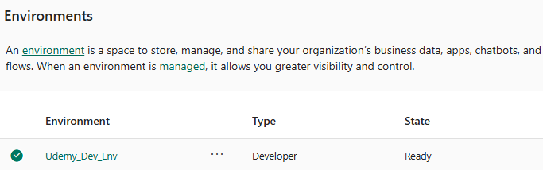

## CREATE AN AGENT WITH COPILOT STUDIO

* In a web browser, navigate to [Copilot Studio](https://copilotstudio.microsoft.com/) at https://copilotstudio.microsoft.com/, signing in with work or school account if prompted. Skip any welcome messages.

|  |
| --- |
| **Note**: The first time we open Copilot Studio, it may display a chat interface to create your first agent. If this happens, click the **…** menu at the top right (next to the **Create** button) and select **Cancel agent creation** to leave the chat interface and view the Copilot Studio home page. |

1. View the Copilot Studio home page, which should look like this:

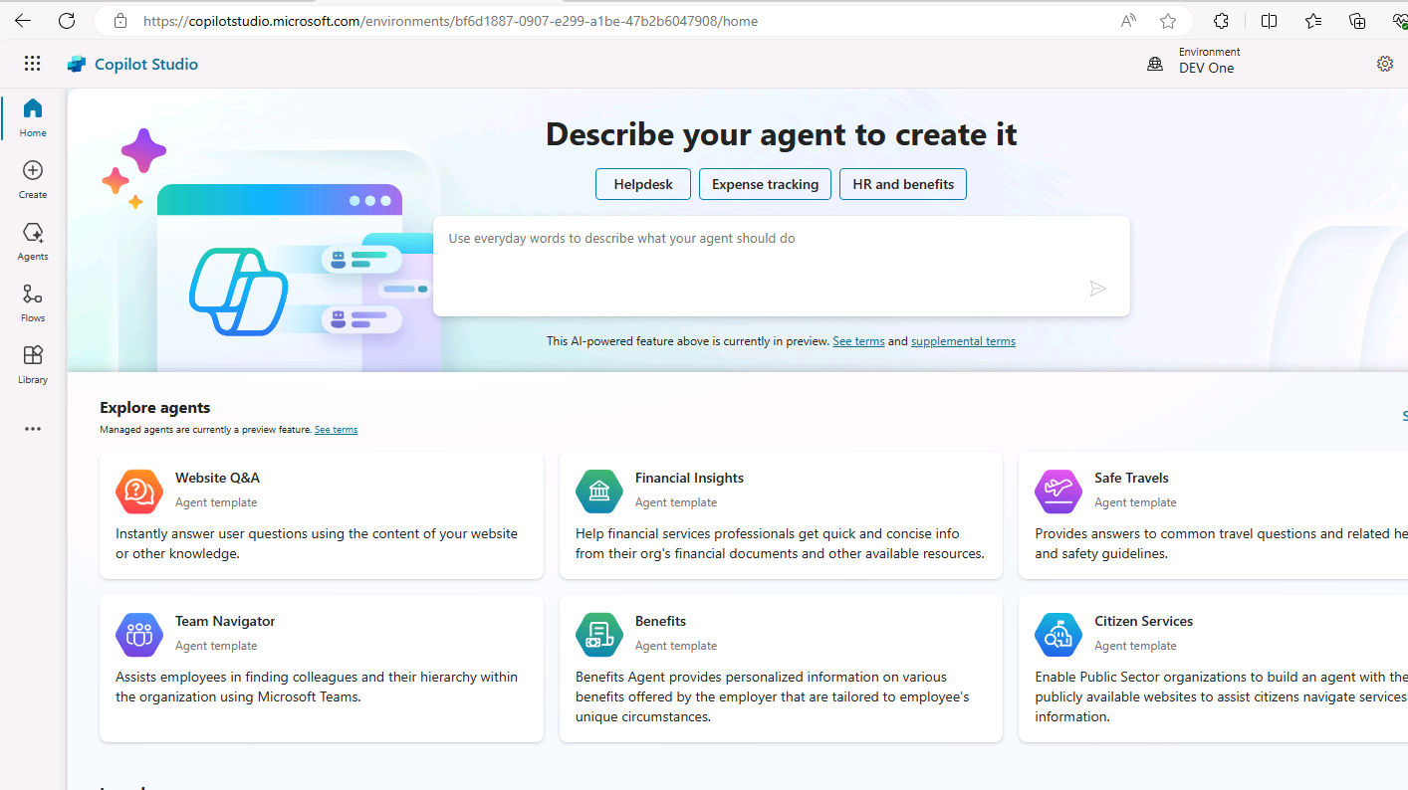

* On the home page, we can start creating an agent and view agents we have recently worked on.
* The Power Apps **environment** in which your agents are defined is shown at the top of the page.
* We can also navigate to the **Create** page for more agent creation options and the **Agents** page to view all existing agents.



* **Note**: In addition to agents you have created, you may see **Copilot for Microsoft 365**, which you can use Copilot Studio to extend.

1. In the navigation pane on the left, select **Create** to view a page on which you can create a new agent, like this:

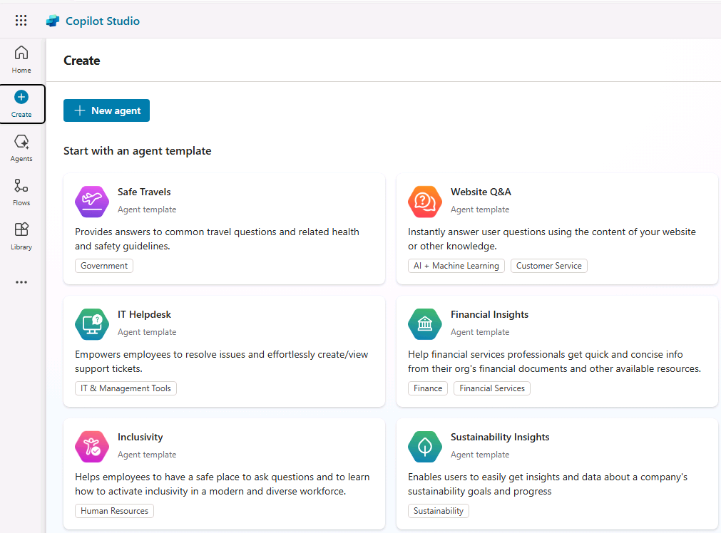

You can create a completely new agent or start with a template. In this exercise, you'll create a brand-new agent.

1. Select the option to create a **New agent**. Copilot Studio responds by providing a chat interface in which you can describe the functionality of the agent you want to build.

|  |
| --- |
| **Tip**: You can use the **Skip to Configure** option to skip the chat-based agent creation experience. In this exercise, we'll use the chat interface |

1. Enter the following prompt:

**Prompt: Create an agent to help employees with expense claims.**

1. Review the response from Copilot Studio. The chat pane should look similar to the following:

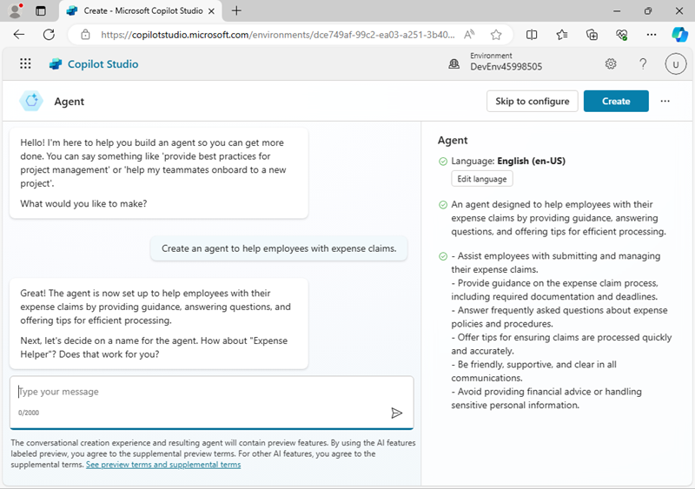

1. Continue the conversation to define your agent, which should:
   * Have an appropriate name
   * Use a friendly, professional tone.
   * Not use any publicly accessible websites to get its information (you'll add a source of knowledge for your agent later).
   * Avoid providing any tax advice.

When you're done, a preview of the chat interface for your agent is displayed beside the conversation used to create it.

1. When you're ready, select **Create** at the top right to create your agent. After a short while, it will be displayed like this (you can unpin the pane on the left to see it more clearly):

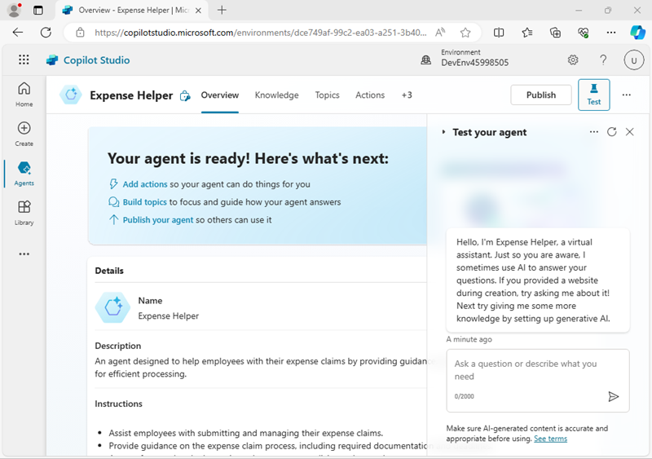

1. In the **Test your agent** pane, enter the following prompt:

|  |  |
| --- | --- |
| **PROMPT** | **RESPONSE** |
| Hello | Review the response, which should be an appropriate message |
| Who should I contact about submitting an expense claim? | This time the response may be appropriate, but it's also likely to be fairly generic. In a real organization, you'd want the agent to provide an email address of phone number for the user to contact. |
| What's the expense limit for a hotel stay? | Again, the response may be appropriate but generic. In a real organization, you'd want the agent to provide a more specific response based on the company's expense policies |

1. Close the **Test your agent** pane.

## MANAGE *TOPICS* IN YOUR AGENT

### TOPIC OVERVIEW

You can use *topics* to provide explicit responses to *triggers*, such as common questions or requests that you expect your users to enter.

1. In the page for your agent, select the **Topics** tab to see its topics.

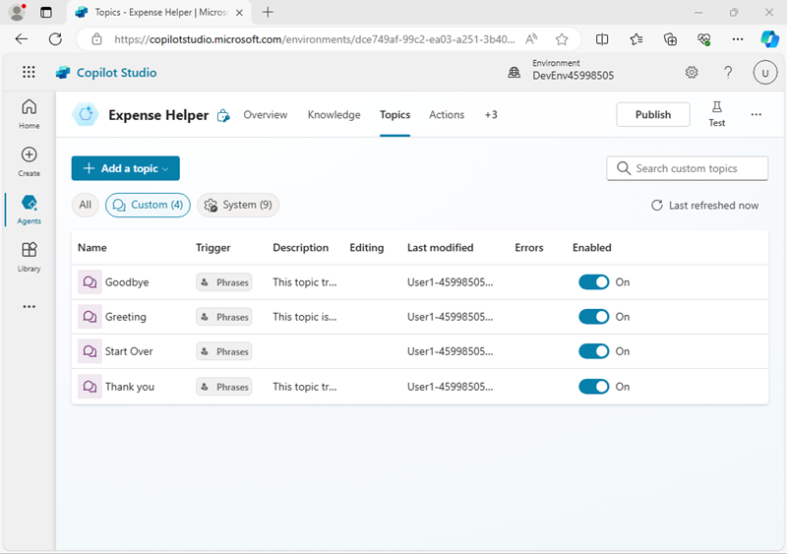

The agent has a few ***Custom*** topics that are triggered by input from the user, and some additional ***System*** topics that are triggered by specific events, such as errors or unexpected input. You can filter the topics by category or use the **All** filter to see them all.

1. Select the **Greeting** custom topic to view it on the *authoring canvas*, which is a visual designer for creating and editing topics and looks similar to this:

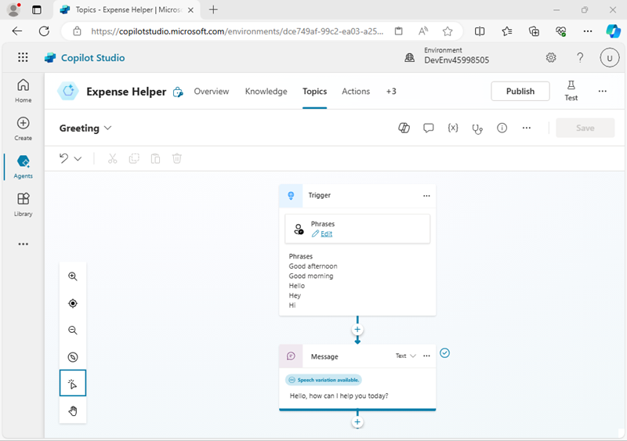

The *Greeting* topic is triggered by an input in which one of the following phrases is present:

* + *Good afternoon*
  + *Good morning*
  + *Hello*
  + *Hey*
  + *Hi*

The response to this trigger is to return a message to the user saying ***Hello. How can I help you today?*.** The inclusion of this topic in the agent explains the response you saw previously when testing it.

1. Return to the **Topics** page, and view the **System** topics. Note that these include topics for common events in a conversation. In particular, note the following system topics:
   * **Conversational boosting**: This topic is triggered when the user submits a message for which the agent can't identify a corresponding topic (the user's *intent* is unknown). The topic then attempts to respond to the user's message by using generative AI.
   * **Fallback**: This topic is a "fail-safe" topic that responds when the intent is unknown and an appropriate conversational AI response can't be generated. The fallback topic includes logic to enable the user to try again up to three times before gracefully ending the conversation, often by escalating to a human operator.

### CREATING TOPIC

* Click on the Agent 🡪 Overview
* Disable the below Configuration

#### CREATING TOPIC FROM BLANK

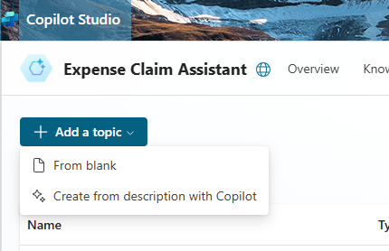

##### ADD THE TRIGGER PHRASE

* Name of the Topic: Vacation Policies

##### ADD THE MESSAGE

* Message is the response text from Copilot Agent .Click on (+) 🡪 Select “**Send Message**”
* Add the message in the “message box”

|  |  |
| --- | --- |
|  |  |
| Save & Test the Copilot Agent after Refreshing |  |

#### CREATING TOPIC WITH COPILOT

1. Return to the **Topics** page, and in the **+ Add a topic** menu, select **Topic** 🡪 **Create from description with Copilot**.
2. In the **Create from description with Copilot** dialog box,
   * **Name the new topic** Ask about expenses contact
   * Enter the following text to tell Copilot Studio what the topic should do:

|  |  |
| --- | --- |
| prompt | When the user asks who to contact about expense claims, tell them to send an email to finance@contoso.com. |

1. Select **Create**.

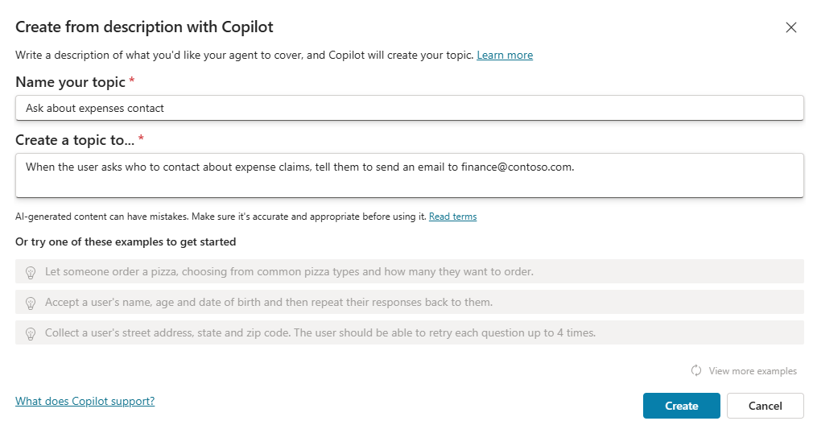

1. If prompted, select **Allow** for **see text and images copied to the clipboard**.
2. After a short wait, a new topic named ***Ask about expenses contact*** should be created and opened in the authoring canvas, where it should look like this:

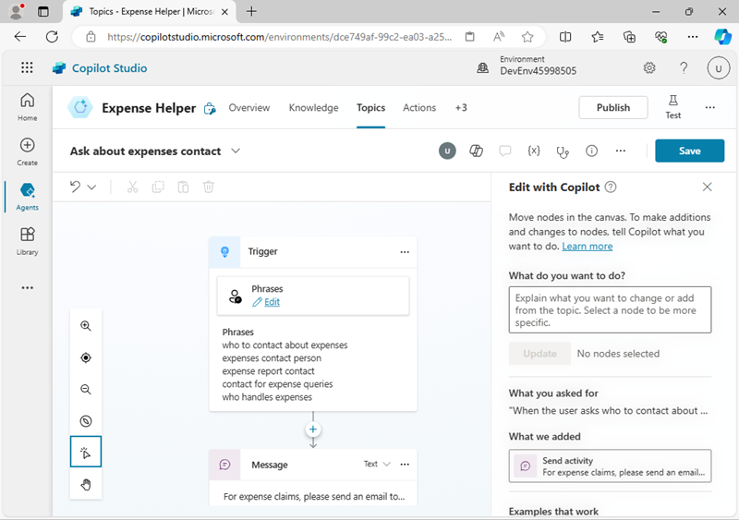

The new topic should be triggered by phrases that ask about a contact for expenses and respond with a message telling the user to send an email to the appropriate address.

**Important**: If the nodes in the topic are different from the above image, delete the topic, and create the topic again.

1. Use the **Save** button (at the top right) to save the new topic in your agent.
2. Open the **Test** pane, and enter the following prompt: **Who should I contact about submitting an expense claim?**

View the response, which should be based on the topic you just added (even though the text you entered doesn’t match any of the phrases in the trigger exactly - it should be close enough semantically to trigger the topic).

#### ASKING QUESTION TO USER

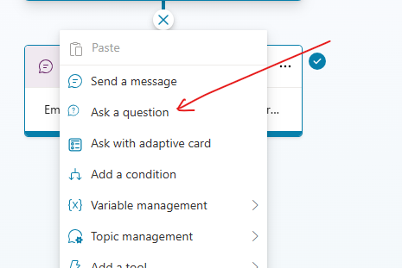

* In this exercise – We will as question from the user before giving response.

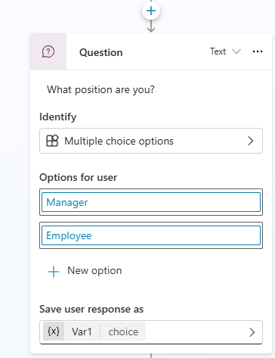

|  |  |
| --- | --- |
|  | * To Add condition , add the condition box corresponding to each option in the Question Box |

**OVER ALL FLOW CHART**

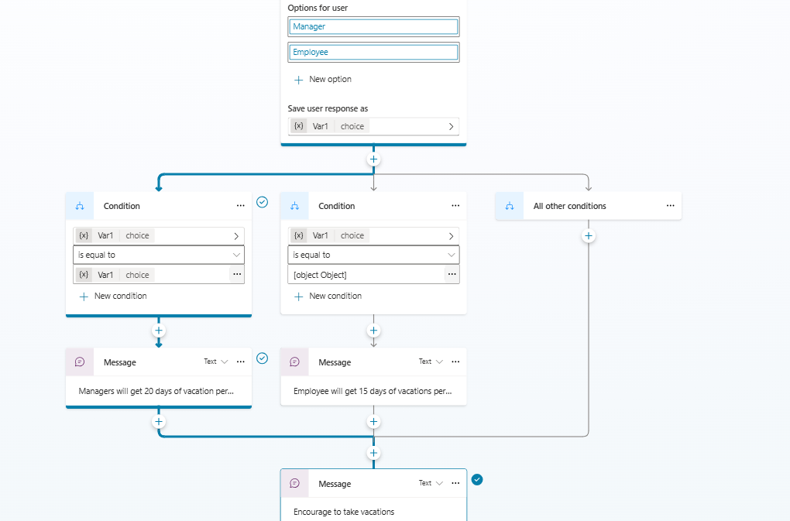

TEST YOUR AGENT

#### PUBLISHING THE AGENT

##### PUBLISH ON CHANNELS

* Go to Channels 🡪 Select a Channels (for example Teams or Website)
* To use the Agent in a Demo website which can be user publicly without authentication
* Go to Settings 🡪 Security 🡪 Authentication 🡪 No Authentication 🡪 Save
* Publish the Agent

* Go to Channels and Click 🡪 Demo website

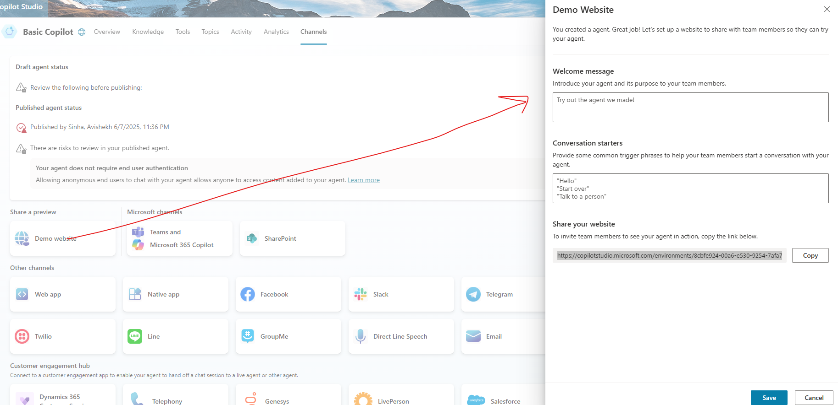

* Save 🡪 Copy the link 🡪 Open the URL in a Browser .

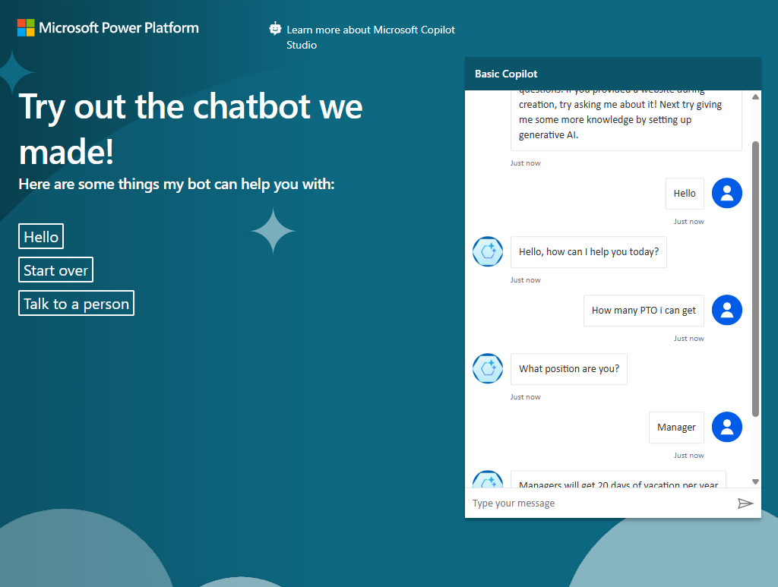

EMBEDDING IN CUTOM WEBSITE

* The above example of for demo website. We can embed it a custom website too
* Click on WebApp 🡪 Copy the Emded code(as an iframe) and paste in the HTML of the WebApp

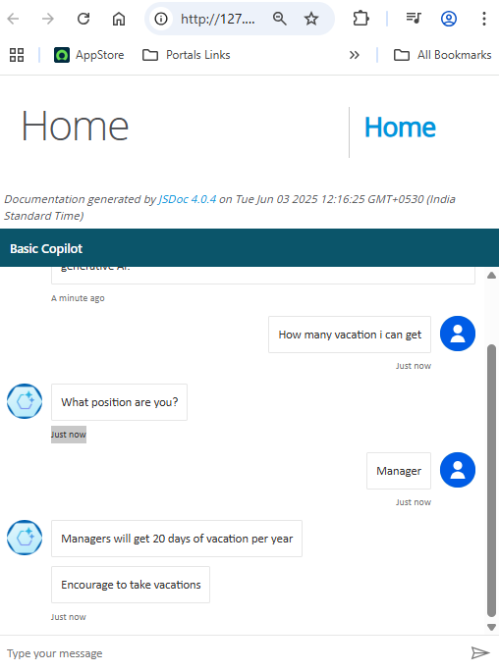

## ADD A KNOWLEDGE SOURCE FOR GENERATIVE AI RESPONSES

You can add topics for all of the inputs that you expect a user to enter; but you can’t realistically expect to anticipate every question that will be asked. Currently, your agent uses a ***Conversation boosting*** topic to generate AI responses from a language model, but this results in generic answers. You need to provide a source of knowledge in which the generative AI responses can be *grounded* to provide more relevant information.

1. Open a new browser tab and download the [expenses policy document](https://raw.githubusercontent.com/MicrosoftLearning/mslearn-copilotstudio/main/expenses/Expenses_Policy.docx) file from <https://github.com/MicrosoftLearning/mslearn-copilotstudio/raw/main/expenses/Expenses_Policy.docx> , saving it locally. This document contains details of the expenses policy for the fictional Contoso corporation.
2. Return to the browser tab for Copilot Studio and close the **Test your agent** pane to see the page more easily, then select the **Knowledge** tab to see the knowledge sources defined in your agent (currently there should be none).

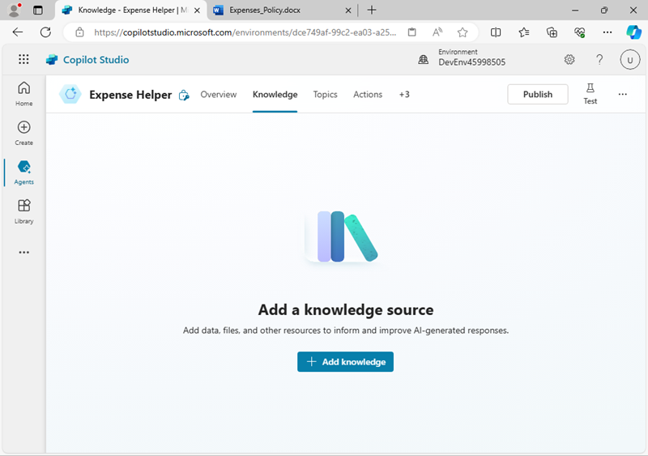

1. Select **+ Add knowledge** and note the multiple types of knowledge source that you can add to your agent.

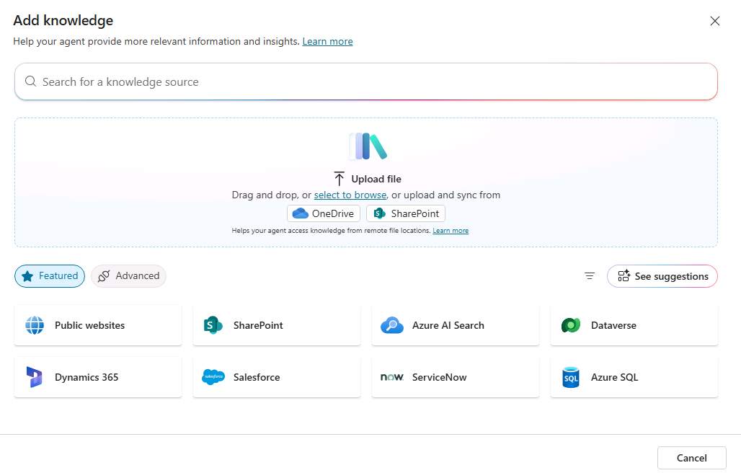

1. In the **Upload file** section, upload the expense policy document you downloaded previously and add it to your agent's knowledge.

|  |
| --- |
| **Note**: After uploading the file, you will need to wait while it is indexed; which may take 10 minutes (or longer). |

1. When the file is ready, view the **Topics** page and open the **Conversational boosting** system topic. Recall that this topic is triggered by an unknown intent, and then tries to create a generative AI response based on data sources containing knowledge; such as the file you uploaded.

|  |
| --- |
| **Note**: If no relevant answer is found in the custom knowledge sources you have added, the topic may use the knowledge inherent in the language model to provide a more generic answer. You can configure the topic to restrict its search to specific knowledge stores if you want greater control over the generative AI responses it returns. |

1. Expand the **Test** pane and restart the conversation. Then enter the following prompt:

|  |  |
| --- | --- |
| Prompt | What's the expense limit for a hotel stay? |
| **The response should be based on the information in the knowledge source you uploaded, and include a citation reference.** | |

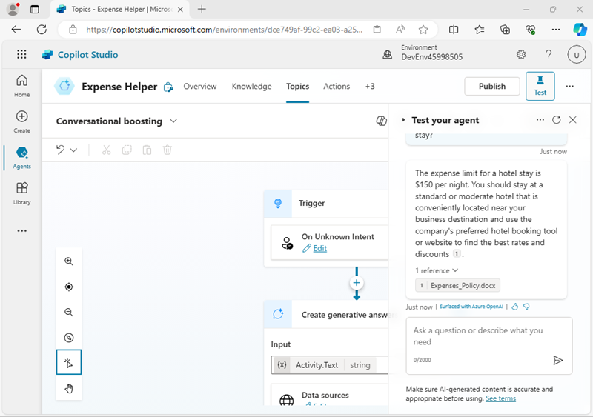

1. Try asking some follow-up questions, such as:
   * What about flights?
   * What guidelines are there for entertainment expenses?

## PUBLISH YOUR AGENT

Now that you have a working agent, you can publish it for people to use. The available channels through which you can deliver your agent depend on the type of authentication you want to use to restrict access to it. In this case, you’ll enable access for anyone and then publish the agent for use in a demo web page.

1. Hide the **Test your agent** pane. Then, at the top of the page, select the **Channels** tab and review the channels to which you can deploy your agent. The available channels depend on the authentication settings for your agent.
2. Select **Settings** at the top of the page.
3. In the **Settings** pane, on the **Security** page, select **Authentication**. Then select the option for **No authentication** and **Save** the changes to the configuration and **Save** again (confirming that you want to enable access to the agent for everyone).
4. Close the **Settings** pane. Then, view the **Channels** page.
5. At the top of the page, select **Publish**. Then, on the **Publish** page, select **Publish**. Publishing will take a minute or so.
6. After your agent has been published, verify the **Publish status** on the **Channels** page.

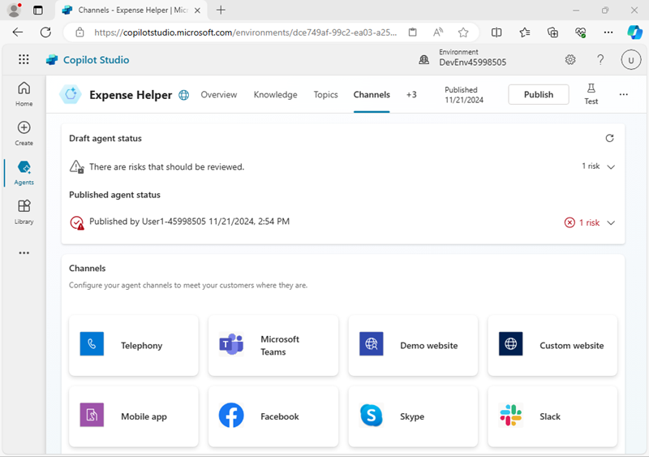

1. Select the **Demo website** channel. This is an appropriate channel for users to test your agent.
2. In the **Demo website** pane, enter the following settings:
   * **Welcome message**: Ask me about Expense claims
   * **Conversation starters**:

|  |  |
| --- | --- |
| prompt | "Hello"  "Who should I contact with expense enquiries?"  "What are the expense limits for flights?"` |

1. Select **Save** to save the settings. Then **Copy** the link to your agent demo website to the clipboard.
2. In a new browser tab, navigate to the URL you copied to open the demo website, which should look similar to this:

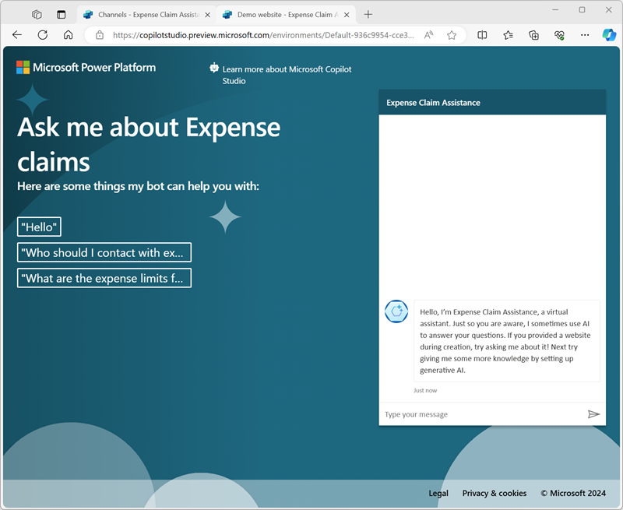

1. Enter the message **-  What are the expense limits for meals**? - and view the response.
2. Try a few more questions and view the responses from your agent. It will have limited functionality but should be able to provide relevant answers to questions about expense claims.

|  |
| --- |
| **CHALLENGE**  Now that you’ve seen how to use Copilot Studio to create a simple agent, it’s time to apply what you’ve learned on your own. Try creating an agent that provides answers to questions about Microsoft Copilot!   * Create a new agent. * Use the <https://www.microsoft.com/en-us/microsoft-copilot/>  website as a knowledge source. * Publish the agent so that users can test it in a demo website.   **Tip**: If you need help, consult the [Copilot Studio documentation](https://learn.microsoft.com/microsoft-copilot-studio/) at <https://learn.microsoft.com/microsoft-copilot-studio/> . |

## IMPORT DATAVERSE SOLUTION

|  |
| --- |
| **WHAT IS DATAVERSE?**   * **Microsoft Dataverse** is a **cloud-based data platform** that allows you to **securely store and manage data** used by business applications. * It’s a core component of the **Microsoft Power Platform** and is deeply integrated with tools like **Power Apps**, **Power Automate**, **Power BI**, and **Copilot Studio**.   **KEY FEATURES OF DATAVERSE**   1. **Structured Data Storage**    * Stores data in the form of **tables** (formerly called entities), similar to a database.    * Each table has **columns (fields)** and **rows (records)**. 2. **Security & Governance**    * Built-in **role-based security** and **data access control**.    * Supports **compliance** with enterprise-grade standards. 3. **Integration Ready**    * Seamlessly integrates with **Microsoft 365**, **Dynamics 365**, **Azure**, and **third-party services**.    * Supports **Power Automate flows**, **Power Apps**, and **Copilot Studio** for building intelligent apps and bots. 4. **Rich Data Types**    * Supports text, numbers, choices, lookups, files, images, and even **relationships between tables**. 5. **Business Logic**    * Add **rules, workflows, and calculated fields** directly within the data layer. 6. **AI & Analytics**    * Works with **Power BI** for reporting and **AI Builder** for predictive insights.   **WHY USE DATAVERSE?**   * Centralized, secure data storage for all your Power Platform apps. * Reduces the need for custom databases or spreadsheets. * Enables **reusability** of data across multiple apps and copilots. * Makes it easier to **scale**, **maintain**, and **analyze** business data. |

IN THIS EXERCISE, YOU'LL IMPORT A DATAVERSE SOLUTION TO USE IN THE FOLLOWING LABS.

|  |
| --- |
| **Note**: This exercise assumes you already have a Copilot Studio license or have signed up for a [free trial](https://go.microsoft.com/fwlink/p/?linkid=2252605) and have a Power Platform environment to work in. |

### Exercise 1 – Import solution:

In this exercise, you will import a Dataverse solution into your environment that contains the tables needed for the labs.

#### Task 1.1 – Sign in to Power Apps

1. In a new browser tab, navigate to <https://make.powerapps.com> .
2. If prompted for credentials, sign in with your email address and password.
3. If prompted for contact information, set the Country/region and select **Get Started**.
4. In the upper-right of the screen, verify that the **Environment** is set to your environment. This is where you will be working for the entirety of the labs. If it is not, select the appropriate environment.

#### Task 1.2 – Download solution

1. Go to [**Bookings_1_0_0_0.zip**](https://raw.githubusercontent.com/MicrosoftLearning/mslearn-copilotstudio/refs/heads/main/Allfiles/Bookings_1_0_0_0.zip) in GitHub. The file is located at <https://github.com/MicrosoftLearning/mslearn-copilotstudio/blob/main/Allfiles/Bookings_1_0_0_0.zip>
2. Select the **ellipses (…)** near the top-right and select **Download**.

#### Task 1.3 – Import solution

1. Go to <https://make.powerapps.com> .
2. Make sure you are in the appropriate environment.
3. In the left navigation, select **Solutions**.
4. In the top bar, select **Import solution**.
5. Select **Browse** and locate the **Bookings_1_0_0_0.zip** file and select **Open**.

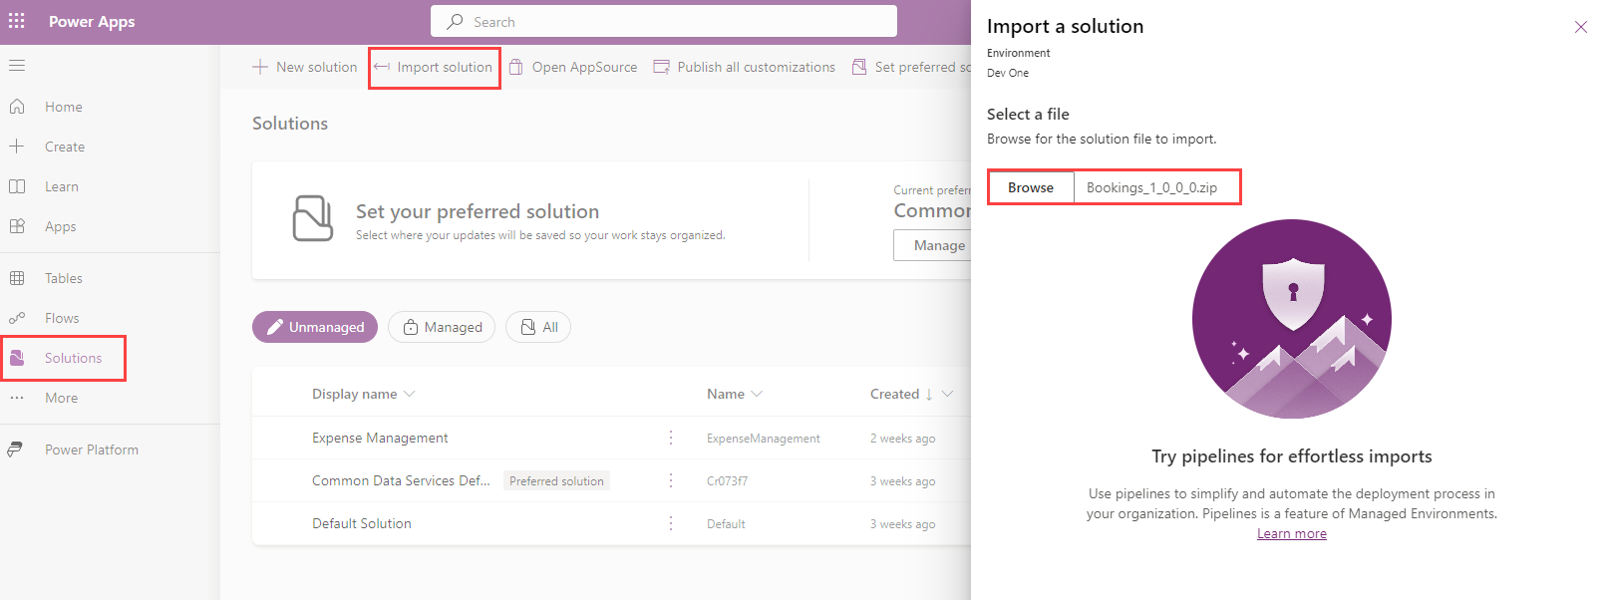

1. Select **Next**.
2. Select **Import**.

The solution will import in the background. This may take a few minutes.

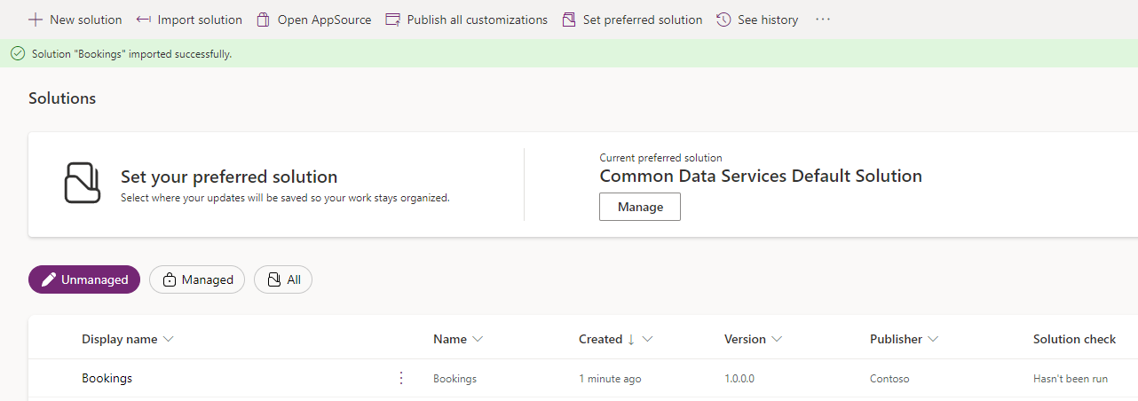

**Alert:** Wait until the solution has finished importing before continuing to the next step.

1. When the solution has imported successfully, open the **Bookings** solution.
2. In the left navigation, select the **Overview** tab.

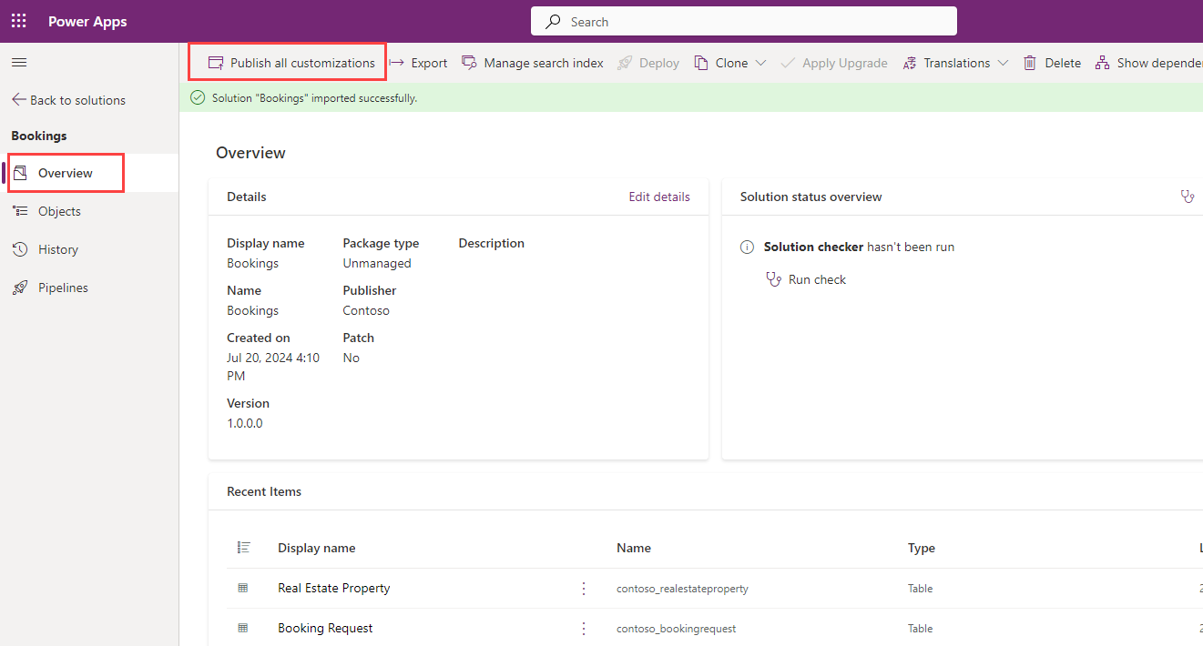

1. Select **Publish all customizations**.

#### Task 1.4 – Test data

1. In the left navigation of the Bookings solution, select the **Objects** tab.
2. Select the **ellipsis …** menu for the **Real Estate Property Management** Model-Driven App, and select **Play**.

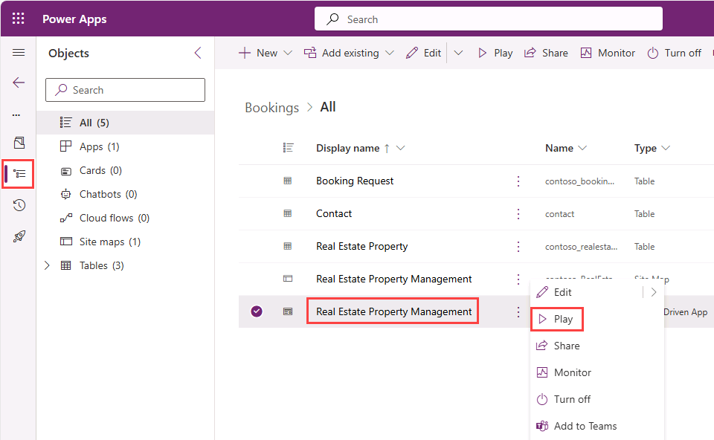

1. Select **+ New**.

|  |  |
| --- | --- |
| 1. Enter the following data:    * **Property Name:** 1100 High Villas    * **Owner:** Select your user    * **Asking Price:** 250,000    * **Street:** Main Avenue    * **City:** Redmond    * **Bedrooms:** 3    * **Bathrooms:** 2 | Overview. |

1. Select **Save & Close**.
2. Select **+ New**.

|  |  |
| --- | --- |
| 1. Enter the following data:    * **Property Name:** 555 Oak Lane    * **Owner:** Select your user    * **Asking Price:** 300,000    * **Street:** Oak Lane    * **City:** Denver    * **Bedrooms:** 4    * **Bathrooms:** 3 | Overview. |

## BUILD AN INITIAL AGENT

Scenario

In this exercise, you will:

* Create and name an agent
* Add description for what the agent should do
* Configure Generative AI answers

This exercise will take approximately **15** minutes to complete.

What you will learn

* How to create an agent using natural language
* How to configure Generative AI answers for an agent

High-level lab steps

* Create a new agent
* Tell your agent what its primary purpose is and how it should act
* Add Generative AI instructions

Prerequisites

* Must have completed **Lab: Import Dataverse solution**

### Exercise 1 - Create agent

In this exercise, you will access the Microsoft Copilot Studio portal, the Developer environment and create a new agent.

#### Task 1.1 – Microsoft Copilot Studio portal

1. In a new tab, navigate to the Microsoft Copilot Studio portal <https://copilotstudio.microsoft.com>  and sign in with your Microsoft 365 credentials if prompted again.
2. If prompted, select **Start free trial**.
3. Make sure that you are in the appropriate environment.

#### Task 1.2 – Create an agent

1. Select **Create** from the left navigation pane and select the **+ New agent** and **Skip to configure** in the top right.
2. In the **Name** text box, enter **Real Estate Booking Service**
3. In the **Description** text box, enter **Create bookings for real estate properties**
4. In the **Instructions** text box, enter **Create an agent for topics relating to creating bookings for real estate properties**
5. At the top, **Language** should be set to **English (en-US)**.

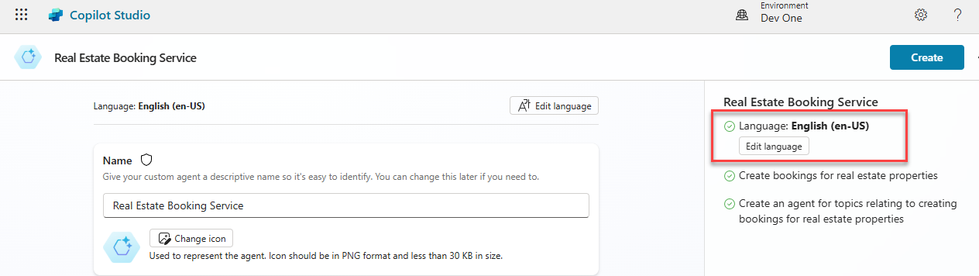

1. Select the **three dots** in the upper-right of the page and select **Edit advanced settings**.

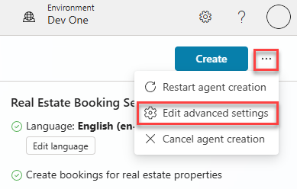

1. Select **Bookings** under **Solution**.
2. Enter labagent for **Schema Name**.

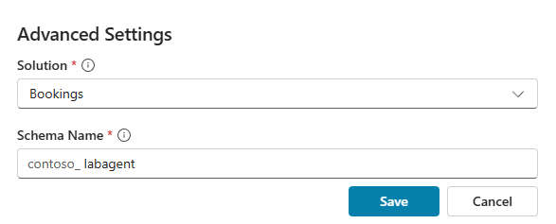

1. Select **Save**.
2. In the upper-right of the screen, select **Create**.
3. In the right **Test your agent** pane, enter **How do I make a booking?**. View the response.

Leave this window open.

### EXERCISE 2 - ADD GENERATIVE AI ANSWERS

In this exercise, you will access the Microsoft Copilot Studio portal and add knowledge that the agent will use to answer questions by using Generative AI.

#### Task 2.1 - Disable generative orchestration

1. In the **Overview** tab, ensure that **Use generative AI to determine how best to respond to users and events.** is set to **Disabled** within the **Details** section.

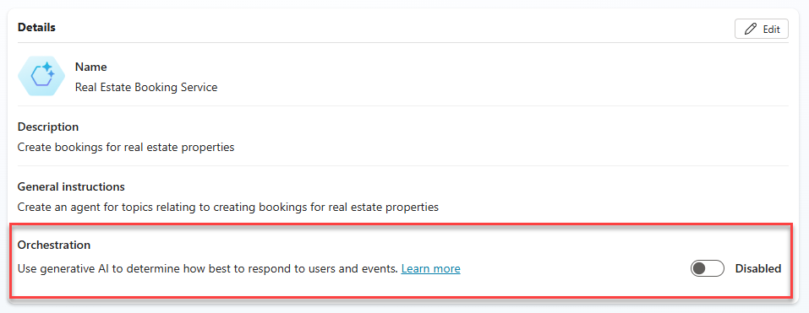

#### Task 2.2 – Enable Generative AI answers

1. In the **Overview** tab, ensure that **Allow the AI to use its own general knowledge** is set to **Enabled** within the **Knowledge** section.

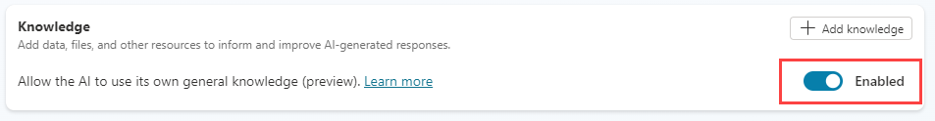

Task 2.3 – Add a knowledge source

1. Select the **Knowledge** tab.

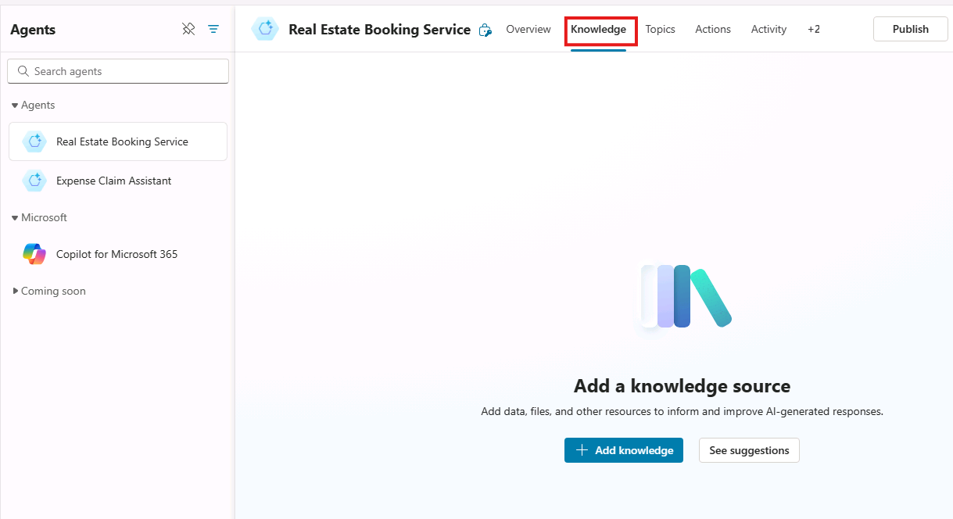

1. Select **+ Add knowledge**.
2. Select **Public websites**
3. In the **Public website link** text box, enter **https://create.microsoft.com/en-us/**.

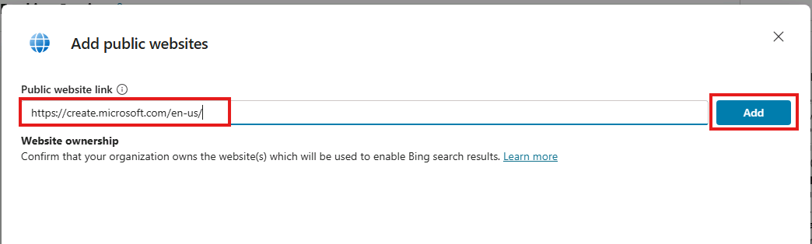

1. Select **Add**.
2. Select **Add**.
3. Select the **Overview** tab.
4. Select the **three dots** at the top of the **Test your agent** pane.
5. Enable **Track between topics**.

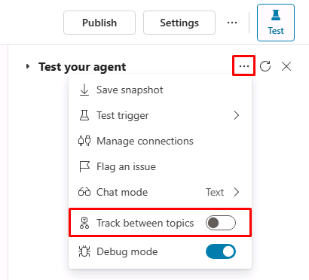

1. At the top of the **Test your agent** pane, select the **Start a new conversation** icon (refresh icon).

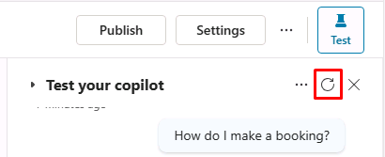

1. In the **Ask a question or describe what you need** text box, enter **How do I boost real estate promotion?**.

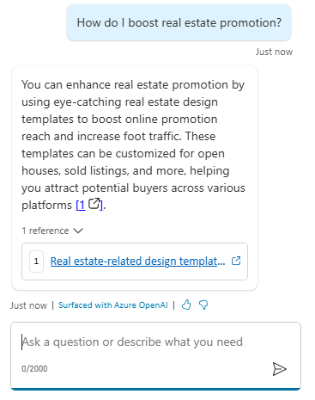

Create agents in Microsoft Copilot Studio

Manage topics

Scenario

In this exercise, you will:

* Manage existing topics
* Create and edit topics by using natural language
* Create a topic manually by using trigger phrases

This exercise will take approximately **30** minutes to complete.

What you will learn

* How to configure agent topics

High-level lab steps

* Disable topics
* Create new and edit topics with natural language
* Create a new topic and add trigger phrases

Prerequisites

* Must have completed **Lab: Build an initial agent**

Detailed steps

Exercise 1 - Remove topics

In this exercise, you will remove topics in an agent.

Task 1.1 – Disable topics

1. Navigate to the Microsoft Copilot Studio portal https://copilotstudio.microsoft.com and ensure you are in the appropriate environment.
2. Select the **Test** button in the upper-right of the screen to close the testing panel if the panel is open.
3. Select **Agents** from the left navigation pane.

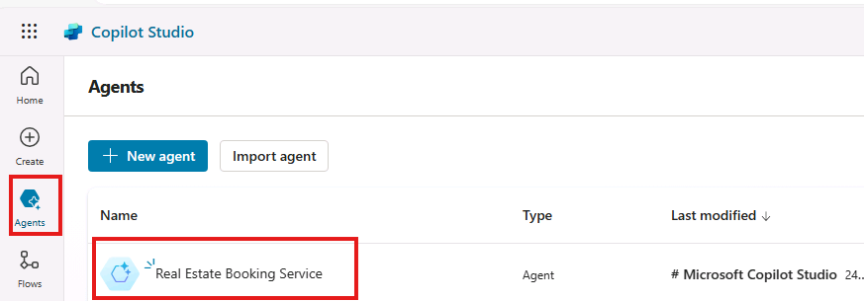

1. Select the agent you created in the previous lab.
2. Select the **Topics** tab.

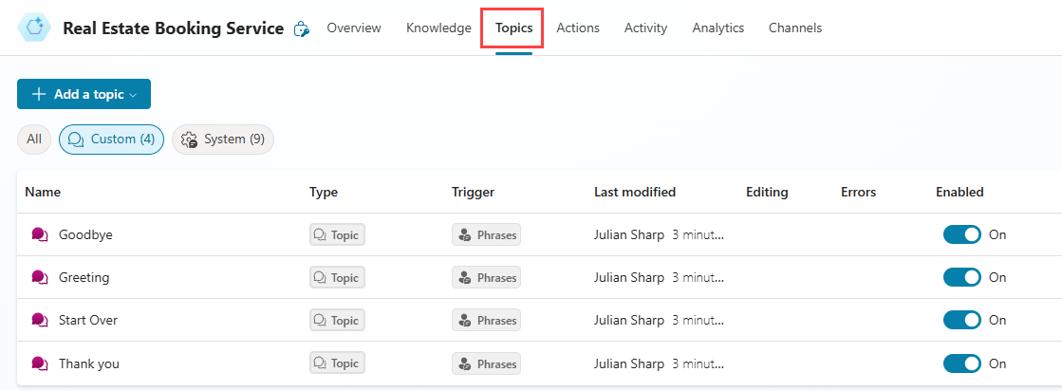

1. Toggle **Enabled** to **Off** for the **Start Over** topic.

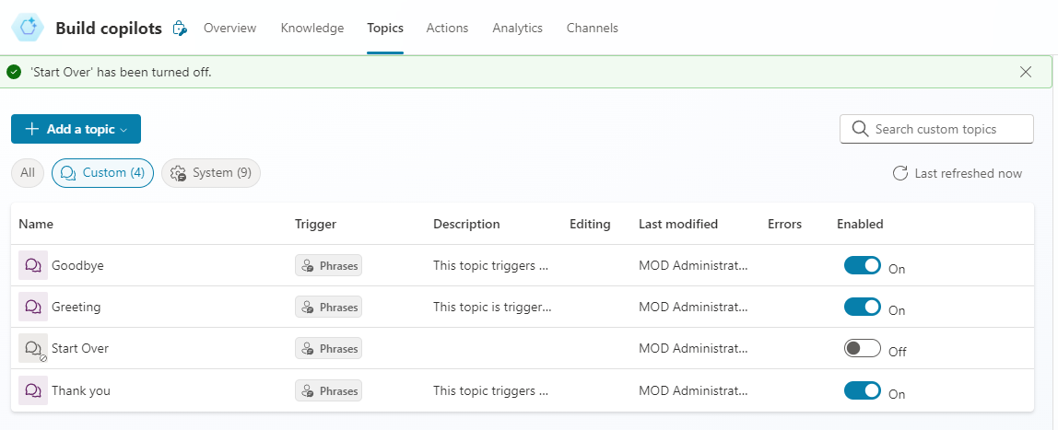

Exercise 2 - Create topics with natural language

In this exercise, you will create topics in an agent and add trigger phrases.

Task 2.1 – Add a topic using copilot

1. Select **+ Add a topic** and select **Create from description with Copilot**. A new window appears.

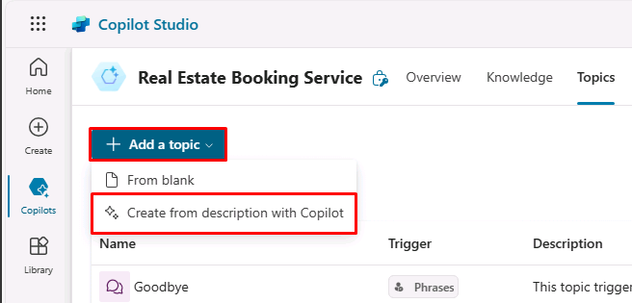

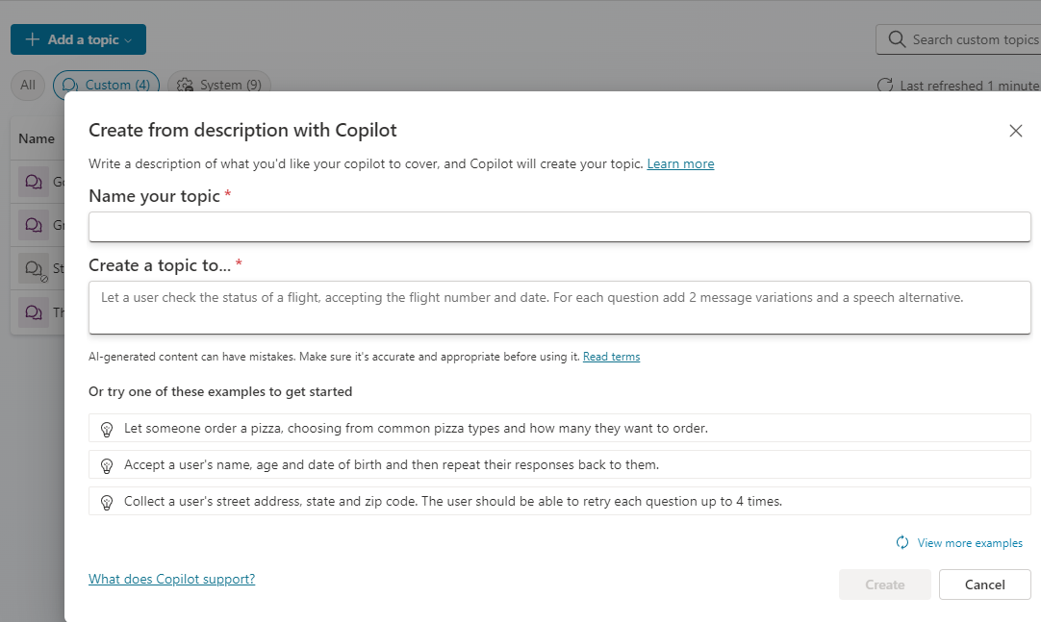

1. In the **Name your topic** text box, enter **Customer Details**.
2. In the **Create a topic to…** text box, enter **Ask the customer for their name and email address.**
3. Select **Create**.
4. Select **Save**.

Task 2.2 – Update nodes with natural language

1. If the **Edit with Copilot** pane is not shown on the right side of the **Customer Details** pane, select the **Copilot** icon in the upper part of the authoring canvas.

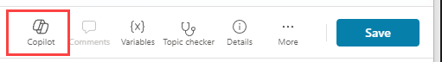

1. Select the second **Question** node, **What is your email address?**

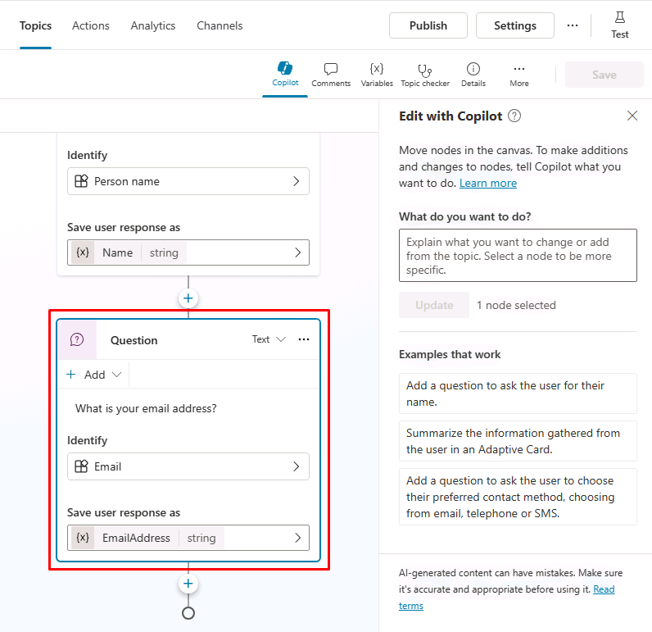

1. In the **Edit with Copilot** panel, in the **What do you want to do?** field, enter the following text:

Change "What is your email address?" to say thank you to the Name variable from the previous node and then proceed to ask the email address question.

1. Select **Update**.

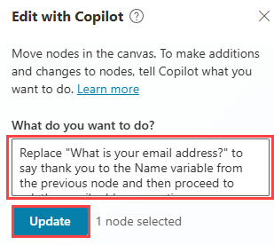

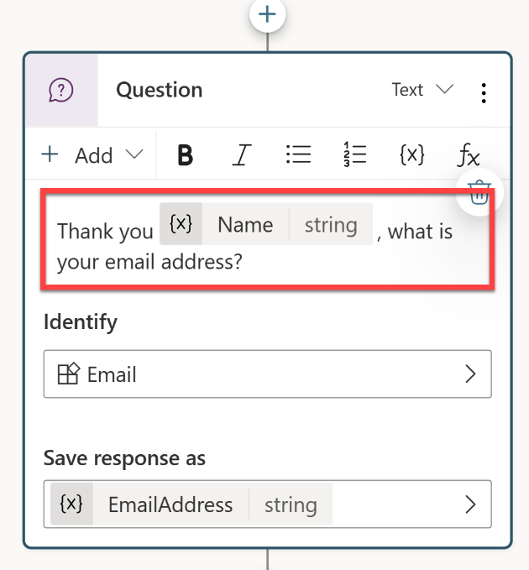

**Note**: The message should be updated to include the *Name* variable from the prior node, and should look similar to the screenshot above. If Edit with copilot did not update the question node correctly, select Undo, and retry with a different prompt.

1. Select **Save**.

Task 2.3 – Add nodes with natural language

In addition to adding updating existing nodes, you can use Copilot to add new ones.

1. Make sure that no node is selected by selecting the empty space around the nodes.
2. In the **Edit with Copilot** panel, in the **What do you want to do?** field, enter the following text:

Summarize the information collected in an adaptive card

1. Select **Update**.
2. A message node with an Adaptive Card is added to the end of the topic.

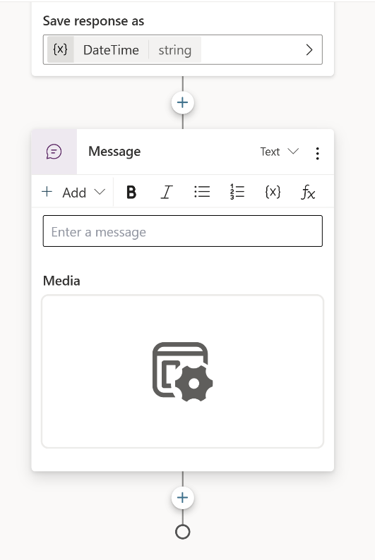

1. Select the **Media** box in the Adaptive Card. The Adaptive Card properties should appear on the right of the screen.

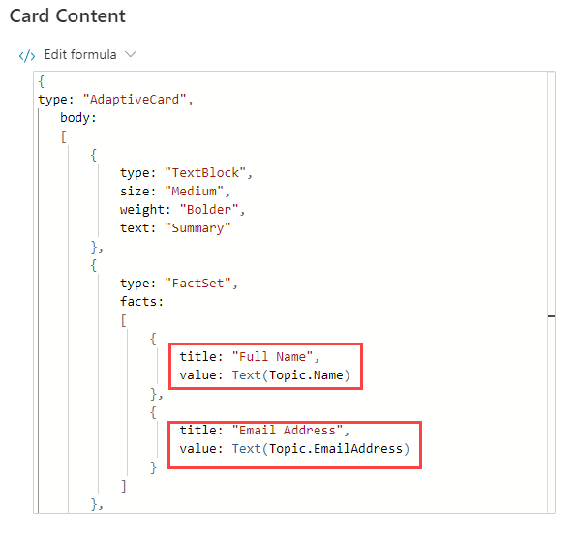

Your Adaptive Card formula should look similar to the one above. If it doesn't, then you can paste in the formula below:

json

{

type: "AdaptiveCard",

body:

[

{

type: "TextBlock",

size: "Medium",

weight: "Bolder",

text: "Summary"

},

{

type: "FactSet",

facts:

[

{

title: "Full Name",

value: Text(Topic.Name)

},

{

title: "Email Address",

value: Text(Topic.EmailAddress)

}

]

},

{

type: "TextBlock",

text: "Thank you for providing the information."

}

]

}

1. Opening the Adaptive Card properties closes the **Edit with Copilot** panel; therefore, you need to select the **Copilot** icon to reopen it.
2. Make sure that no node is selected by selecting the empty space around the nodes.
3. In the **What do you want to do?** field, enter the following text:

Add a new multiple choice question to prompt the user if the details are correct with two options Yes or No

1. Select **Update**.
2. A new question node is added to the end of the topic with options for the user to select.

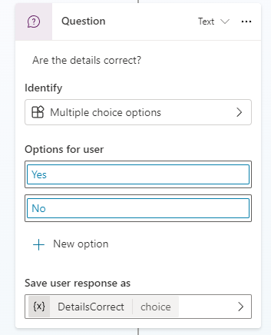

1. Select **Save**.

Task 2.4 - Test the topic

1. Select the **Test** button in the upper-right of the screen to open the testing panel, if it's closed.
2. Select the **Start a new conversation** icon at the top of the testing panel.
3. In the **Ask a question or describe what you need** text box, enter **Customer information**.
4. Enter your name and email address.
5. Select **Yes**.

Exercise 3 - Author topics manually

Topics can be created manually by adding trigger phrases.

Task 3.1 - Create a topic from blank

1. Select the **Topics** tab in the top bar of **Real Estate Booking Service**.
2. Select **+ Add a topic** and select **From blank**.
3. Select the **Details** icon to open the Topic details dialog.

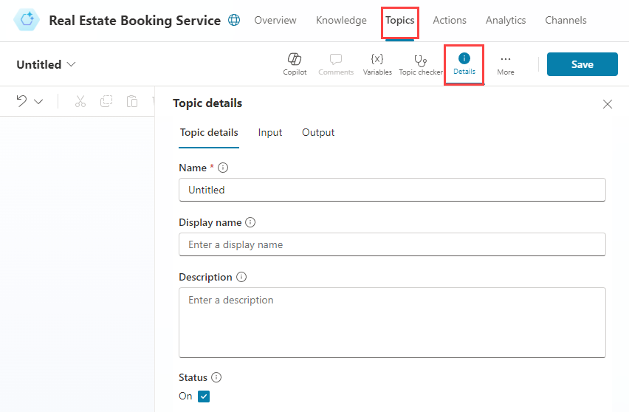

1. In the **Name** field, enter the following text:

Book a Real Estate Showing

1. In the **Display Name** field, enter the following text:

Book

1. In the **Description** field, enter the following text:

Select the property and requested date and create a booking request

1. Select **Save**.

Task 3.2 - Add trigger phrases

1. Select **Edit** under **Phrases** in the **Trigger**.

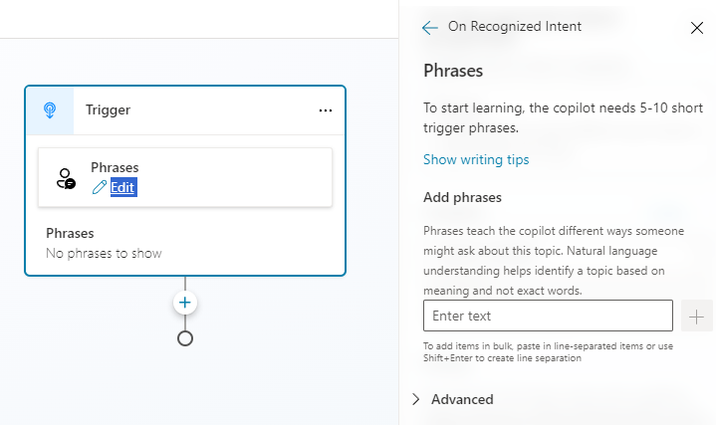

1. Enter I want to book a real estate showing under **Add Phrases** and select the **+** icon.
2. Enter Schedule a real estate showing under **Add Phrases** and select the **+** icon.
3. Enter Arrange the viewing for a real estate property under **Add Phrases** and select the **+** icon.
4. Enter Set up an appointment to view a house under **Add Phrases** and select the **+** icon.
5. Enter Plan a property viewing under **Add Phrases** and select the **+** icon.
6. Select **Save**.

Congratulations!

You have successfully completed this Lab. Click **Next** to advance to the next **Lab**.

Manage nodes

Scenario

In this exercise, you will:

* Author the conversational flow
* Manage variables

This exercise will take approximately **30** minutes to complete.

What you will learn

* How to add nodes to a topic to author the conversational flow

High-level lab steps

* Configure variable scope
* Create and edit nodes
* Deploy and test the agent

Prerequisites

* Must have completed **Lab: Manage topics**

Detailed steps

Exercise 1 - Variable scope

Variables can be accessed by other topics.

Task 1.1 - Configure the scope of the variables

1. Navigate to the Microsoft Studio portal https://copilotstudio.microsoft.com and ensure you are in the appropriate environment.
2. Select the **Test** button in the upper-right of the screen to close the testing panel if the panel is open.
3. Select **Agents** from the left navigation pane.
4. Select the agent you created in the earlier lab.
5. Select the **Topics** tab.
6. Select the **Customer Details** topic.
7. Select **Variables** in the top bar to open the Variables pane.
8. Select the right-hand check boxes for the three topic variables.

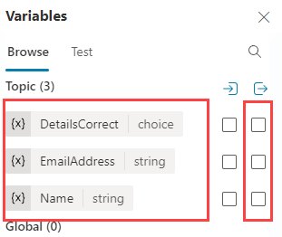

1. Select **Save**.

Exercise 2 - Author topics manually

The conversational flow in a topics can be created manually by adding nodes.

Task 2.1 - Add a message node

1. Select the **Topics** tab.
2. Select the **Book a Real Estate Showing** topic.
3. Select the the **+** icon under the Trigger node and select **Send a message**.

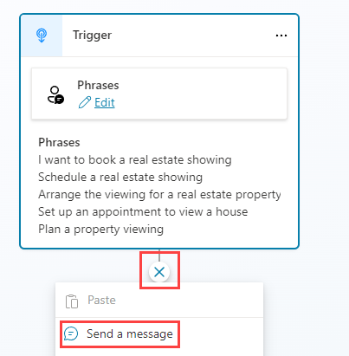

1. In the **Enter a message** field, enter the following text:

Hi, I can help you with booking a real estate property showing.

1. Select **Save**.

Task 2.2 - Add a Topic management node

1. Select the the **+** icon under the **Message** node, **Topic management**, then **Go to another topic**, then select **Customer Details**.

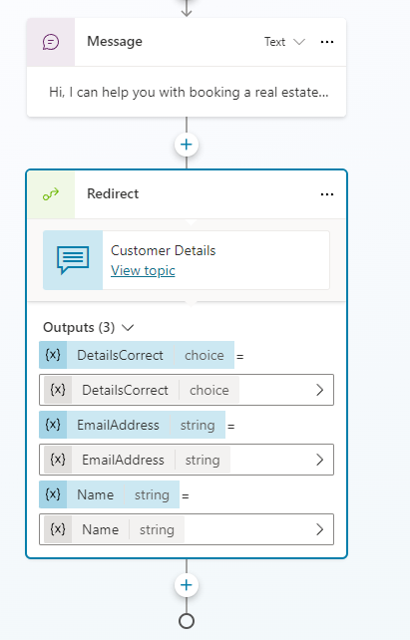

1. Select **Save**.

Task 2.3 - Add condition node

1. Select the the **+** icon under the **Redirect** node and select **Add a condition**.
2. In the **Condition** node, select the **DetailsCorrect** variable.
3. Select **is equal to**.
4. Select **Yes**.

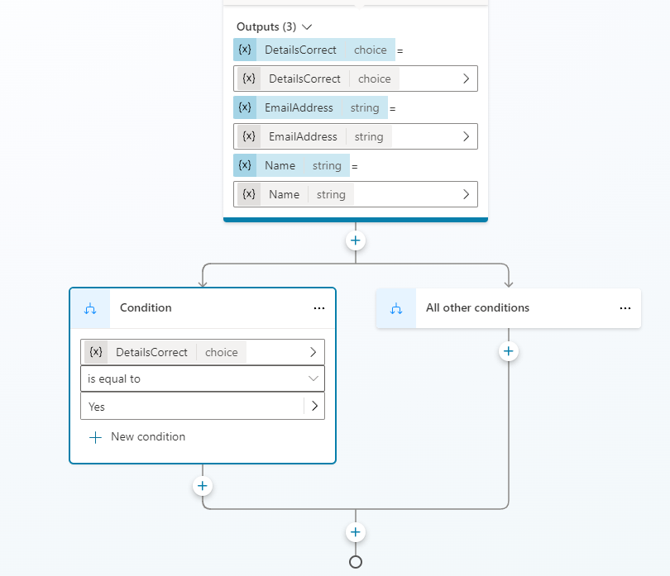

1. Select **Save**.

Task 2.4 - Add question nodes

1. Select the the **+** icon under the left **Condition** node and select **Ask a question**.
2. In the **Enter a message** field, enter the following text:

Which property do you want to see?

1. Select **User's entire response** for **Identify**.
2. Select the variable in **Save user response as** and enter **PropertyName** for **Variable name**.

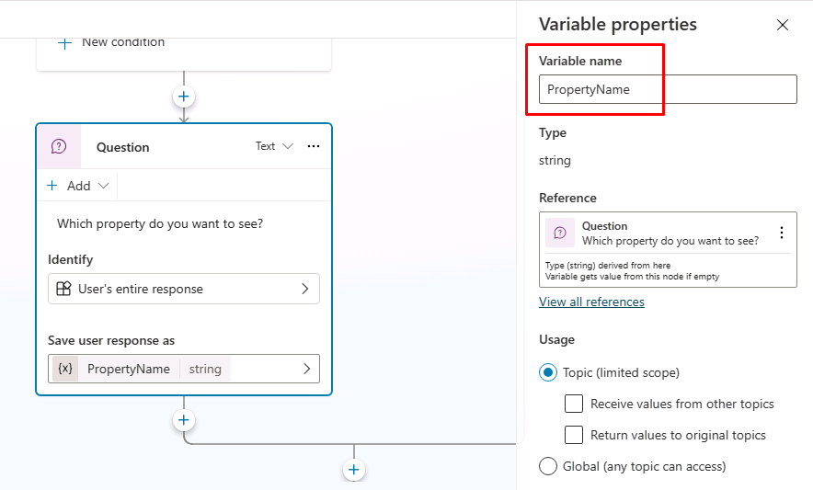

1. Select **Save**.
2. Select the the **+** icon under the new **Question** node and select **Ask a question**.
3. In the **Enter a message** field, enter the following text:

What date and time do you want to see the property?

1. Select **Date and time** for **Identify**.
2. Select the variable in **Save user response as** and enter **DateTime** for **Variable name**
3. Select **Save**.

Task 2.5 - Test the agent

1. If it's not open, select the **Test** button in the upper-right of the screen to open the testing panel.
2. Select the **three dots** at the top of the testing panel in the upper-right of the screen.
3. If it's not enabled, enable **Track between topics**.



1. Select the **Start a new conversation** icon at the top of the testing panel.
2. When the **Conversation Start** message appears, your agent will start a conversation. In response, enter a trigger phrase for the topic that you've created:

I want to book a real estate showing

1. The agent responds with the "What is your name?" question, as shown in the following image.

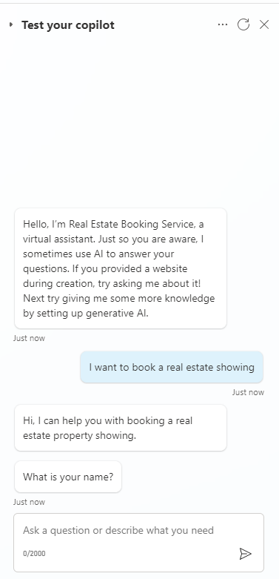

1. Enter your name and email address.
2. After you supply the information, an Adaptive Card displays the information that you entered and asks if the details are correct. Select **Yes**.
3. Enter 555 Oak Lane, Denver, CO 80203 to the **Which property to you want to see?** prompt
4. Enter Tomorrow 10:00 AM to the **What date and time do you want to see the property?** prompt.

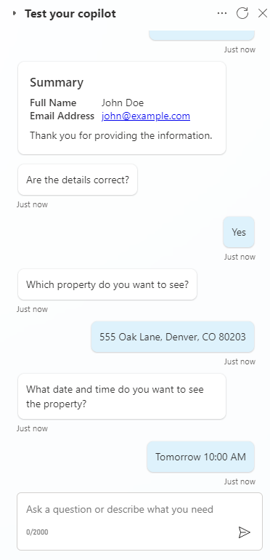

Exercise 3 - Deploy agent

Task 3.1 - Configure Authentication

1. Select **Settings** in the upper-right of **Real Estate Booking Service**.
2. Select the **Security** tab.
3. Select the **Authentication** tile.

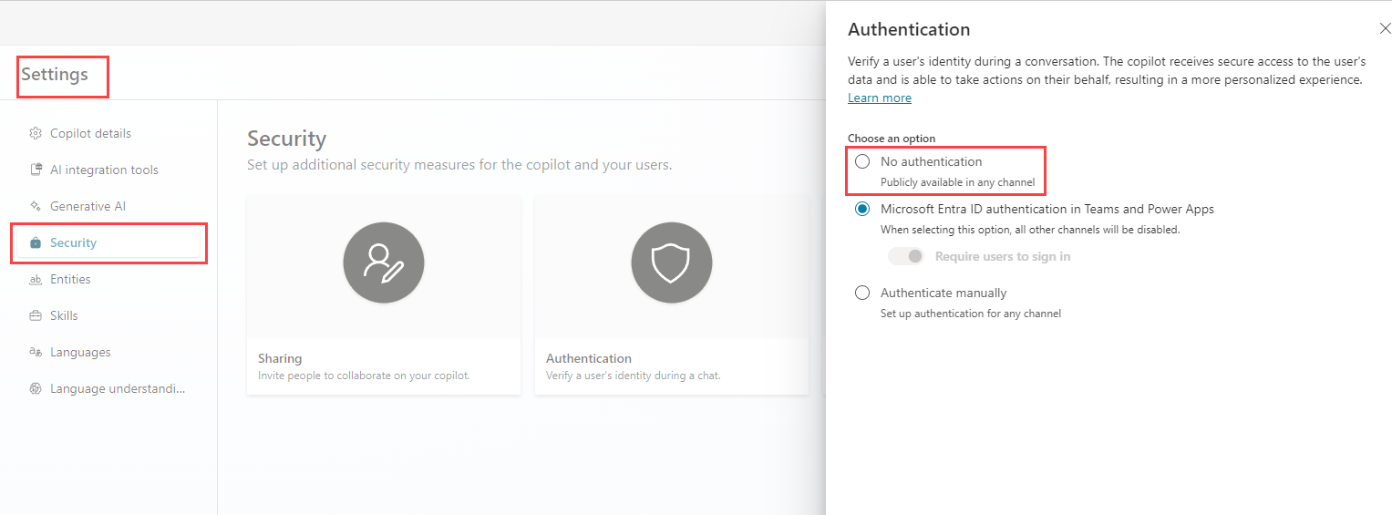

1. Select **No authentication**.
2. Select **Save**.
3. Select **Save** in the confirmation window.
4. Select the **X** in the upper-right to close out of the **Settings**.

Task 3.2 - Publish the agent

1. Select **Publish** in the upper-right, then select **Publish** again.

Task 3.3 - Demo Website

1. Select the **three dots** next to the **Settings** button in the upper-right of the screen and select **Go to demo website**.
2. In the **Type your message** text box, enter **I want to book a property**.
3. Answer the prompts to test the agent.

Congratulations!

You have successfully completed this Lab. Click **Next** to advance to the next **Lab**.

Work with entities

Scenario

In this exercise, you will:

* Create and use entities

This exercise will take approximately **15** minutes to complete.

What you will learn

* How to create and use entities to improve the agent

High-level lab steps

* Create entities
* Use entities in nodes

Prerequisites

* Must have completed **Lab: Manage nodes**

Detailed steps

Exercise 1 - Create entities

Microsoft Copilot Studio uses entities to understand user intent. There are many prebuilt entities included for commonly used information. You can create custom entities for your specific purpose.

Task 1.1 - View prebuilt entities

1. Navigate to the Microsoft Copilot Studio portal https://copilotstudio.microsoft.com and ensure you are in the appropriate environment.
2. Select **Agents** from the left navigation pane.
3. Select the **Real Estate Booking Service** you created in the earlier lab.
4. Select **Settings** in the upper-right of the screen.
5. Select the **Entities** tab.

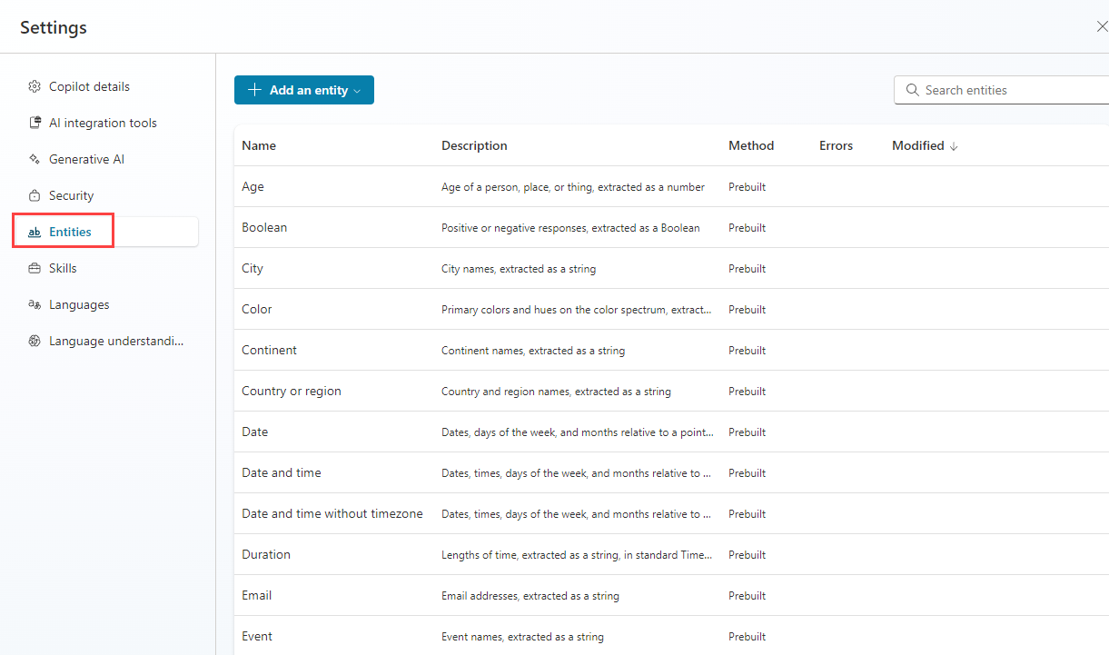

Task 1.2 - Create the property type entity

1. Select **+ Add an entity** and select **+ New entity**.

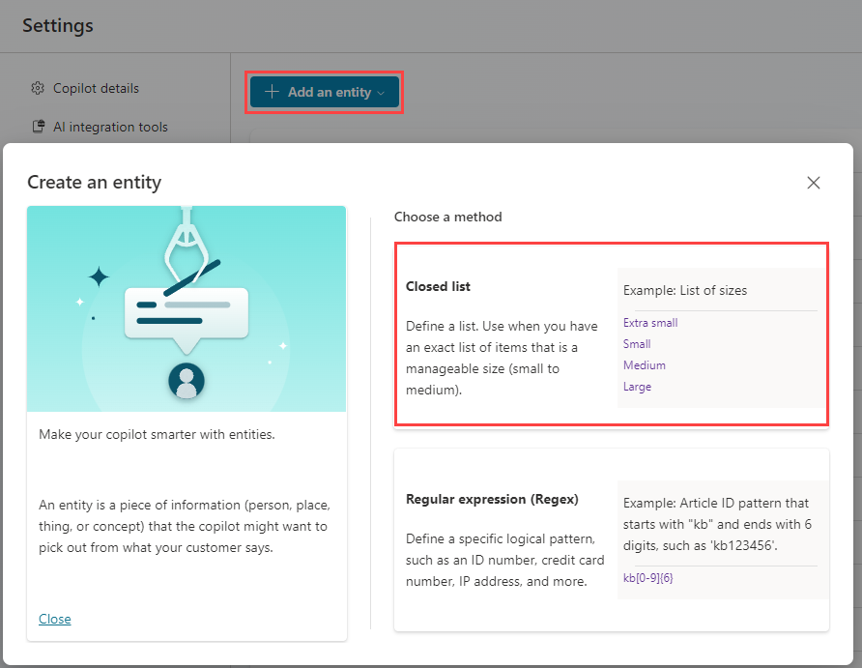

1. Select the **Closed list** tile.
2. Enter **Property Type** in the **Name** field.
3. Enter **Apartment** in the **Enter item** field and select **Add**.
4. Enter **Condominium** in the **Enter item** field and select **Add**.
5. Enter **Duplex** in the **Enter item** field and select **Add**.
6. Enter **House** in the **Enter item** field and select **Add**.
7. Select **+ Synonyms** for **Apartment**, enter **Flat** and select the **+** icon and select **Done**.
8. Select **+ Synonyms** for **Condominium**, enter **Townhouse** and select the **+** icon and select **Done**.
9. Select **+ Synonyms** for **House**, enter **Single-family home** and select the **+** icon and select **Done**.
10. Enable **Smart matching**.

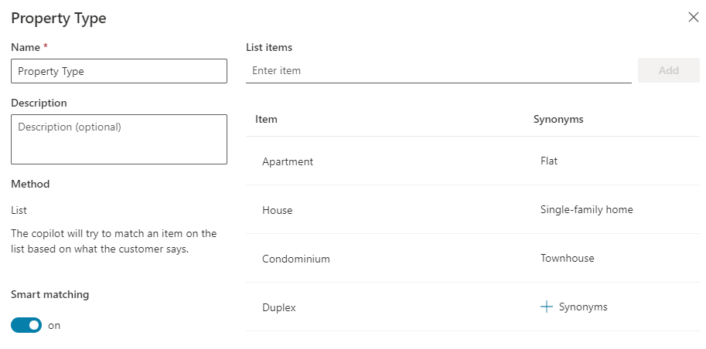

1. Select **Save**.
2. Select **Close**.

Task 1.3 - Create number of bedrooms entity

1. Select **+ Add an entity** and select **+ New entity**.
2. Select the **Regular expression (Regex)** tile.
3. Enter **Number of Bedrooms** in the **Name** field.
4. Enter **[1-5]** in the **Pattern** field.
5. Select **Save**.
6. Select **Close**.

Exercise 2 - Use entities to improve the agent

Use entities in the conversational flow to improve the agent.

Task 2.1 - Use entities

1. Select the **X** icon in the top-right to close out of Settings and return to your agent.
2. Select the **Topics** tab.
3. Select the **Book a Real Estate Showing** topic.
4. Select the the **+** icon between the **Condition** and property **Question** nodes, then select **Ask a question**.
5. In the **Enter a message** field, enter the following text:

What type of property do you want to see?

1. Select **Property Type** for **Identify**.
2. Select **Select options for user** and check the **Display** option for all four values.
3. Select the variable in **Save user response as** and enter **PropertyType** for **Variable name**

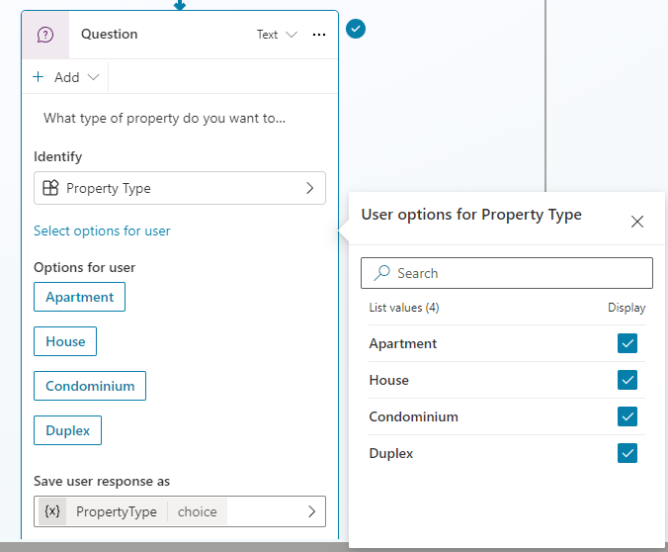

1. Select the the **+** icon below the new **Question** node and select **Ask a question**.
2. In the **Enter a message** field, enter the following text:

How many bedrooms do you need?

1. Select **Number of Bedrooms** for **Identify**.
2. Select the variable in **Save user response as** and enter **NumberofBedrooms** for **Variable name**
3. Select **Save**.

Congratulations!

You have successfully completed this Lab. Click **Next** to advance to the next **Lab**.

Create agent actions

Scenario

In this exercise, you will:

* Create agent actions using Power Automate cloud flows

This exercise will take approximately **30** minutes to complete.

What you will learn

* How to add use Power Automate to access data in Microsoft Dataverse

High-level lab steps

* Create a Power Automate cloud flow to retrieve Dataverse data with an agent action
* Create a Power Automate cloud flow to create Dataverse data with an agent action

Prerequisites

* Must have completed **Lab: Work with entities**

Detailed steps

Exercise 1 - Create agent action to retrieve data from Dataverse

Microsoft Copilot Studio can access data in Microsoft Dataverse using Power Automate cloud flows.

Task 1.1 - Create Power Automate flow to retrieve a property

1. Navigate to the Microsoft Copilot Studio portal https://copilotstudio.microsoft.com and ensure you are in the appropriate environment.
2. Select **Agents** from the left navigation pane.
3. Select the **Real Estate Booking Service** you created in the earlier lab.
4. Select the **Actions** tab.
5. Select **+ Add an action**.
6. Select the **ellipses (…)** and select **Flow**.

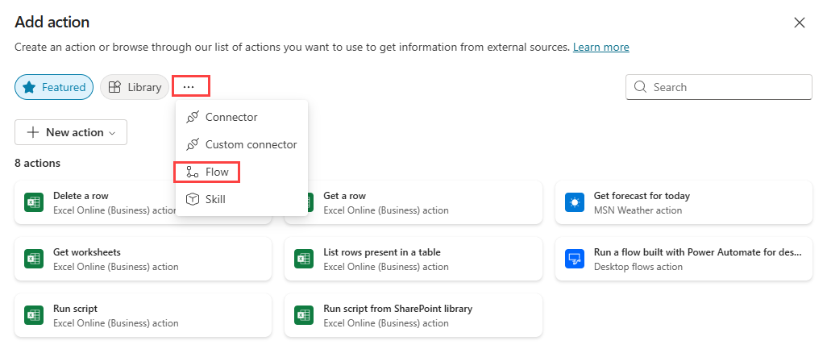

1. Select **New action** and select **New Power Automate flow**.
2. Select **Run a flow from Copilot** in the top-left of the screen and enter Get Property as the flow name.
3. Select the trigger step **When an agent calls the flow** and select **+ Add an input**.
4. Select **Text**.
5. Enter Bedrooms for **Input** and Number of Bedrooms for **Please enter your input**.

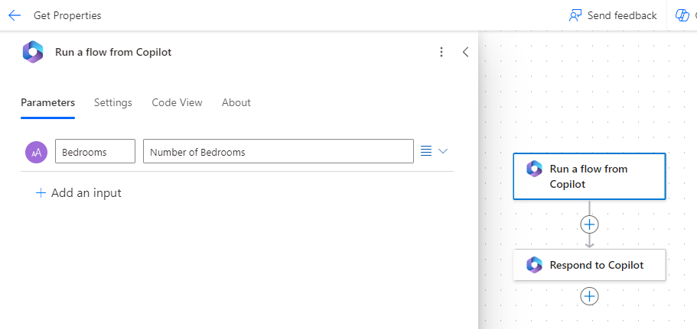

1. Select the **+** icon between the two steps in the flow to add a new action.
2. Enter Dataverse in the **Search** field and select **See more** for the **Microsoft Dataverse** connector.

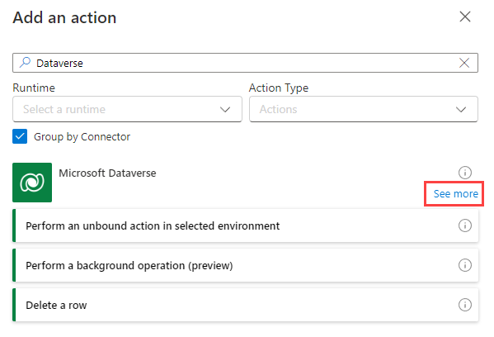

1. Select the **List rows** action.
2. If prompted for authentication, select **OAuth** and select **Sign in**.

**Note:** If you see a '**Failed to create OAuth connection**' error, you may need to allow popups in your browser.

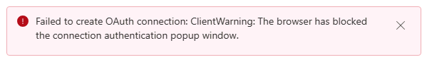

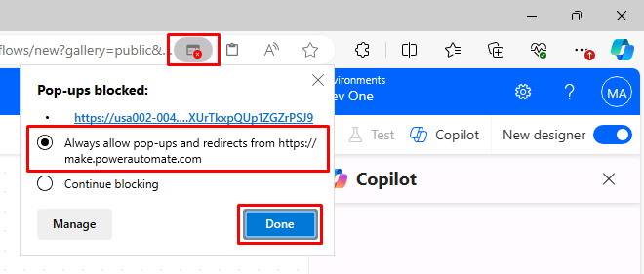

1. Select **Real Estate Properties** for table name.
2. Enter contoso_bedrooms eq (with a space after **eq**) in the **Filter Rows** field.
3. With the **Filter Rows** field still selected, select the **lightning** icon to its right, then select the **Bedrooms** parameter.

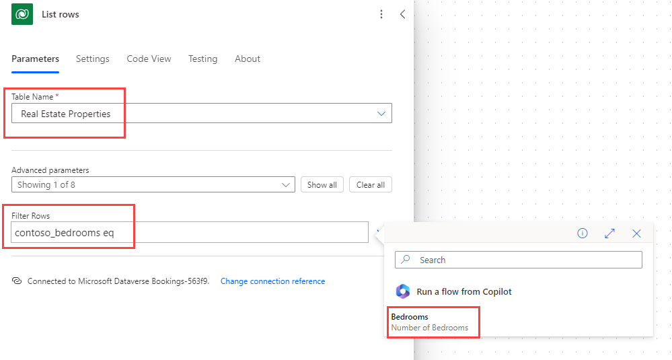

**Important:** Ensure there is a space between eq and Bedrooms.

1. In the main Power Automate pane, select the **Respond to Copilot** action and select **+ Add an output**.
2. Select **Text**.
3. Enter PropertyId for **Enter a name**
4. Select the **Enter a value to respond with** field, and select **fx (Insert Expression)**.
5. Enter the following expression into the top field:

first(outputs('List_rows')?['body/value'])['contoso_realestatepropertyid']

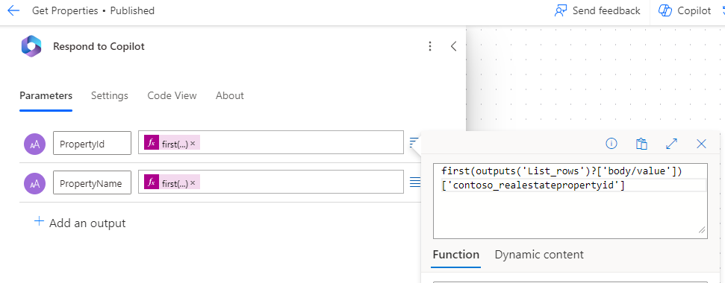

1. Select **Add**.
2. Select **+ Add an output**.
3. Select **Text**.
4. Enter PropertyName for **Enter a name**.
5. Select the **Enter a value to respond with** field, and select **fx (Insert Expression)**.
6. Enter the following expression:

first(outputs('List_rows')?['body/value'])['contoso_propertyname']

1. Select **Add**.
2. Select the **Settings** tab in the **Respond to Copilot** pane.
3. Ensure that **Asynchronous Response** is set to **Off**.

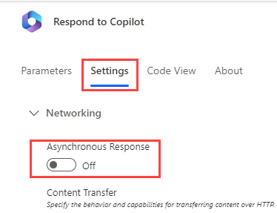

1. Select **Save draft** near the upper-right of the page.
2. Wait for the save to complete, Select **Publish** then close the Power Automate tab once Publishing is complete.

Task 1.2 - Add an agent action to retrieve a property

1. Select **Refresh** from the Copilot Studio dialog box to see the new flow.

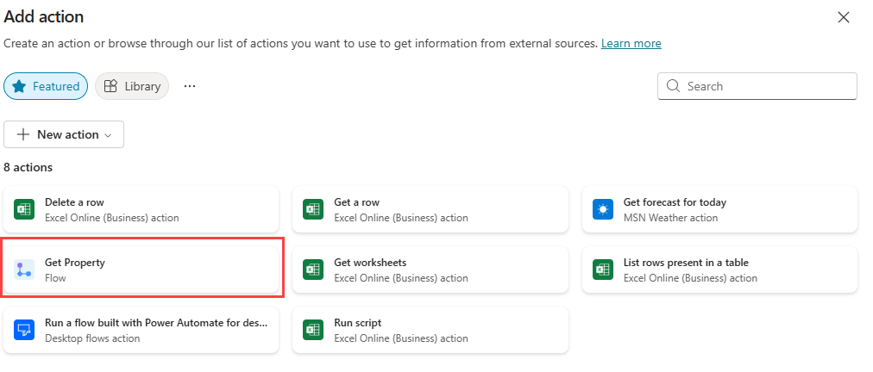

1. Select the **Get Property** flow.
2. Expand **Inputs and outputs**

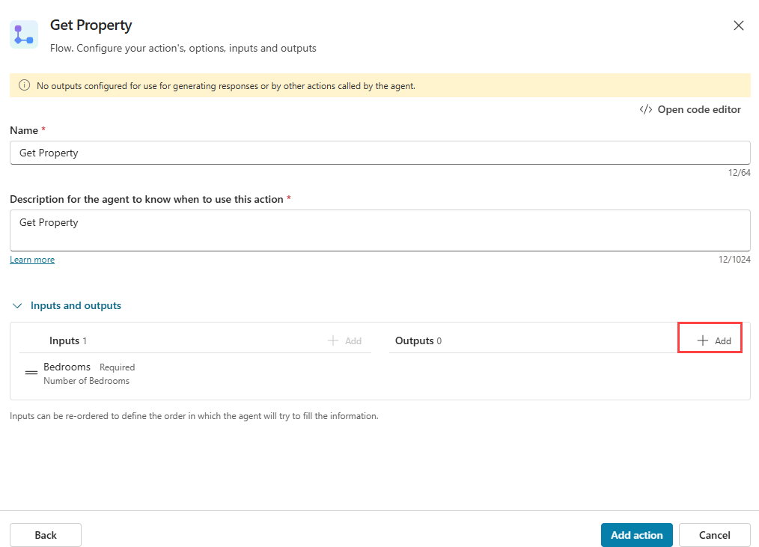

1. Select **+ Add** for **Outputs**.
2. Select **PropertyId**.
3. Select **+ Add** for **Outputs**.
4. Select **PropertyName**.

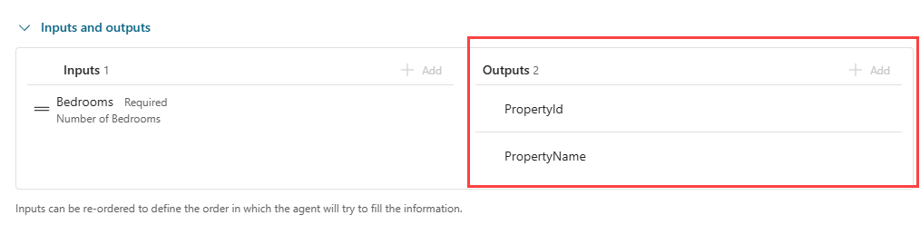

1. Select **Add action**.

Task 1.3 - Add the Get Property agent action to the topic

1. Select the **Topics** tab.
2. Select the **Book a Real Estate Showing** topic.
3. Select the the **+** icon below the **How many bedrooms do you need question?** node, select **Add an action**, then select the **Get Property** flow.

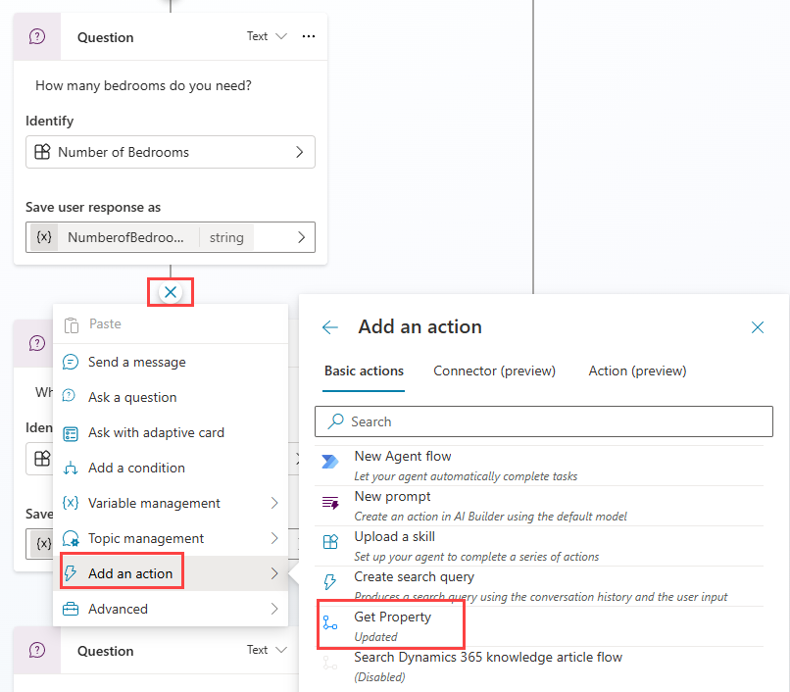

1. Select the **NumberofBedrooms** variable for the **Bedrooms** input parameter.

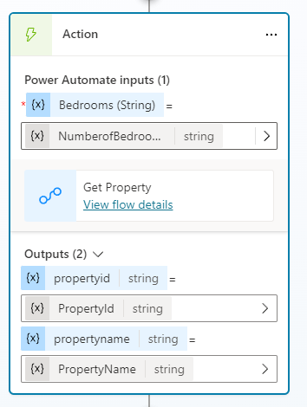

1. Select the **three dots** in the **Which property do you want to see?** question node and select **Delete**.
2. Select the the **+** icon under the **Action** node and select **Send a message**.
3. In the **Enter a message** field, enter Property (with a space following it).
4. In the same node, select the **{X} (Insert variable)** icon and select the **PropertyName** variable.

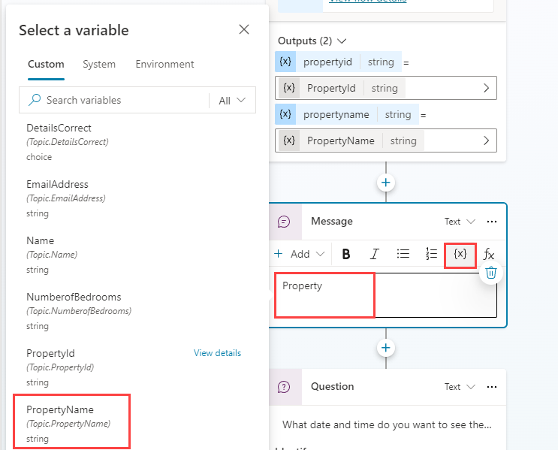

1. Select **Save**.

Exercise 2 - Create agent action to create data in Dataverse

Microsoft Copilot Studio can ceate data in Microsoft Dataverse using Power Automate cloud flows.

Task 2.1 - Create Power Automate flow to make a booking

1. Select the **Actions** tab in **Real Estate Booking Service**.
2. Select **+ Add an action**.
3. SSelect **+ New Action** and then **New Power Automate Flow** .
4. Select **Run a flow from Copilot** in the top-left of the screen and enter Create Booking Request as the flow name.
5. Select the trigger step **When an agent calls the flow** and select **+ Add an input**.
6. Select **Text**.
7. Enter PropertyId for **Input** and Property for **Please enter your input**.
8. Select **+ Add an input**.
9. Select **Text**.
10. Enter ViewerName for **Input** and Viewer Name for **Please enter your input**.
11. Select **+ Add an input**.
12. Select **Text**.
13. Enter ViewerEmail for **Input** and Viewer Email for **Please enter your input**.

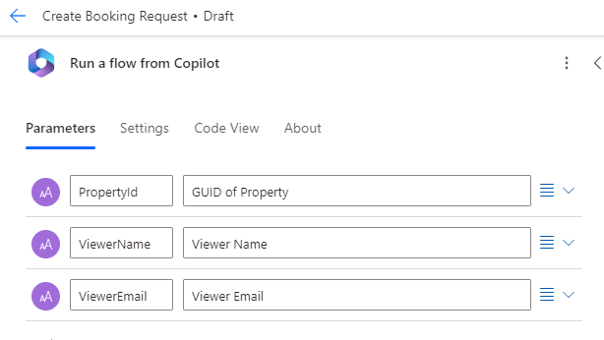

1. Select the **+** icon between the two steps in the flow to add a new action.
2. Enter Dataverse in the **Search** field and select **See more** for the **Microsoft Dataverse** connector.
3. Select the **Add a new row** action.
4. Select **Booking Requests** for table name.
5. Enter Agent booking in the **Booking Name** field.
6. Select **Show all** under **Advanced parameters**.
7. Enter contoso_bookingrequests() in the **Property (Real Estate Properties)** field, move the cursor within the parentheses, select the **lightning** icon, then select the **PropertyId** parameter.
8. Select the **Viewer Email** field, select the **lightning** icon, then select the **ViewerEmail** parameter.
9. Select the **Viewer Name** field, select the **lightning** icon, then select the **ViewerName** parameter.

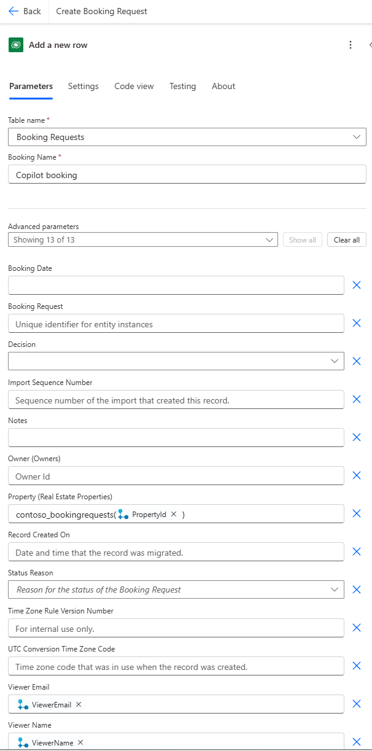

1. Select the **Respond to Copilot** action.
2. Select the **Settings** tab.
3. Ensure that **Asynchronous Response** is set to **Off**.
4. Select **Save draft** in the upper-right of the window.
5. Wait for the save to complete, select **Publish** then close the Power Automate tab.

Task 2.2 - Add an agent action to create a booking request

1. Select **Refresh** from the Copilot Studio dialog box to see the new Flow.
2. Select the **Create Booking Request** flow.
3. Select **Add action**.

Task 2.3 - Add the Create Booking Request agent action to the topic

1. Select the **Topics** tab.
2. Select the **Book a Real Estate Showing** topic.
3. Select the the **+** icon below the **What date and time do you want to see the property?** node, select **Add an action**, then select the **Create Booking Request** flow.
4. Select the **PropertyId** variable for the **PropertyId** input parameter.
5. Select the **Name** variable for the **ViewerName** input parameter.
6. Select the **EmailAddress** variable for the **ViewerEmail** input parameter.
7. Select the the **+** icon below the new **Action** node, select **Topic management**, select **Go to another topic** and select **End of Conversation**.
8. Select **Save**.
9. Select **Publish** and select **Publish** again.

Exercise 3 - Test the agent actions

Task 3.1 - Make a booking request

1. If closed, select the **Test** button in the upper-right of the screen to open the testing panel.
2. Select the **three dots** at the top of the testing panel in the upper-right of the screen.



1. If it's not enabled, enable **Track between topics**.
2. Select the **Start a new conversation** icon at the top of the testing panel.
3. When the **Conversation Start** message appears, your agent will start a conversation. In response, enter a trigger phrase for the topic that you've created:

I want to book a real estate showing

1. Enter the following information:

Name: <Your name>

Email address: <Your email address>

1. After you supply the information, an Adaptive Card displays the information that you entered and asks if the details are correct. Select **Yes**.
2. Select **House** for the type of property prompt.
3. Enter 3 for the number of bedrooms prompts.

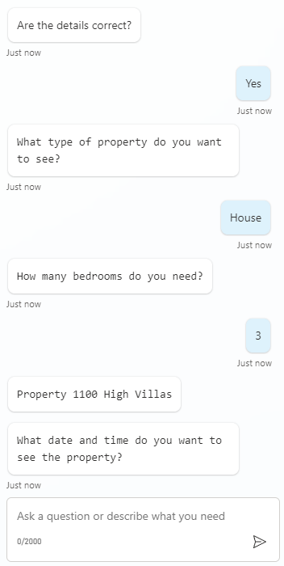

1. Enter Tomorrow 2:00 PM to the **What date and time do you want to see the property?** prompt.
2. Select **Yes** to the **Did that answer your question?** prompt.
3. Select any rating.
4. Enter **No** to the **Can I help with anything else?** prompt.

Task 3.2 - Verify the booking request

1. If it's not still open, navigate to https://make.powerapps.com in a new tab.
2. Make sure you are in the appropriate environment.
3. Select **Play** on the **Real Estate Property Management** model-driven app.
4. In the left navigation, select **Booking Requests**.

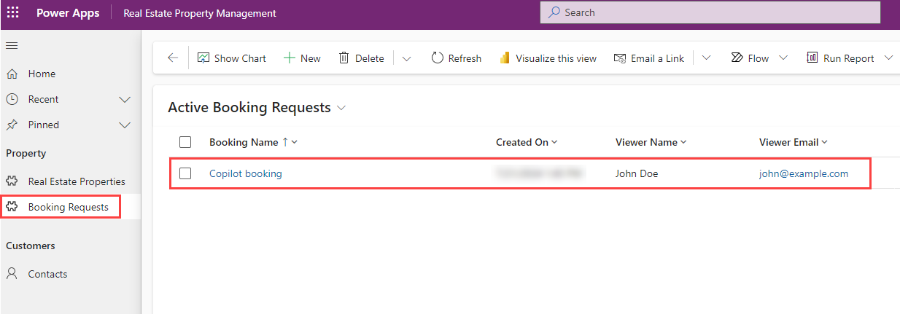

Congratulations!

Use Generative AI in Microsoft Copilot Studio

Scenario

In this exercise, you will:

* Use knowledge and Generative AI in your agent

This exercise will take approximately **30** minutes to complete.

What you will learn

* How to use the Generative answers feature to improve your agent's responses.

High-level lab steps

* Enable Generative AI
* Add knowledge

Prerequisites

* Must have completed **Lab: Create agent actions**

Detailed steps

Exercise 1 - Configure Generative AI

Task 1.1 - Enable Generative AI

1. If it's not still open, go to the Microsoft Copilot Studio portal https://copilotstudio.microsoft.com and ensure you are in the appropriate environment.
2. Select **Agents** from the left navigation.
3. Select the **Real Estate Booking Service** you created in the earlier lab.
4. Select the **Settings** button in the upper-right of the screen.
5. Select the **Generative AI** tab.
6. Select **Generative** under **How should your agent interact with people?**
7. Select **Medium - More Balanced** for **How strict should the content moderation be?**
8. Select **Save**.

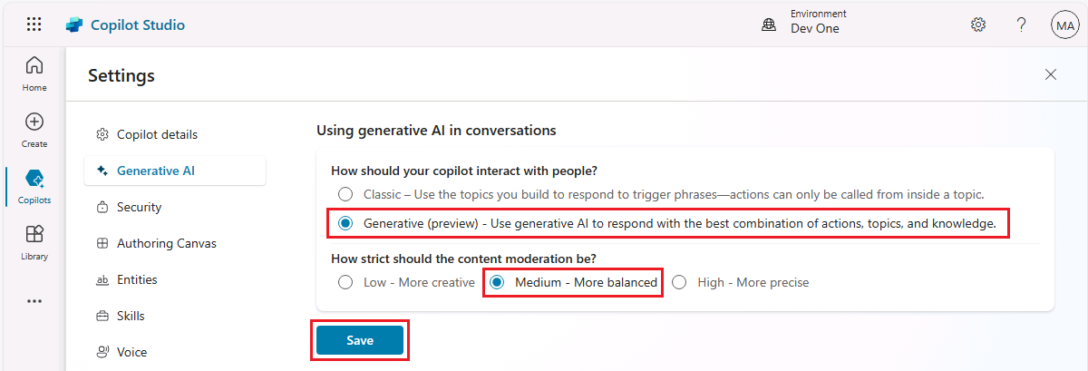

1. Close the **Settings** menu by selecting the **X** icon in the upper-right of Copilot Studio.

Task 1.2 - Use generative answers in the Conversational boosting topic

1. Select the **Topics** tab and select the **System** filter.
2. Select the **Conversational boosting** topic.

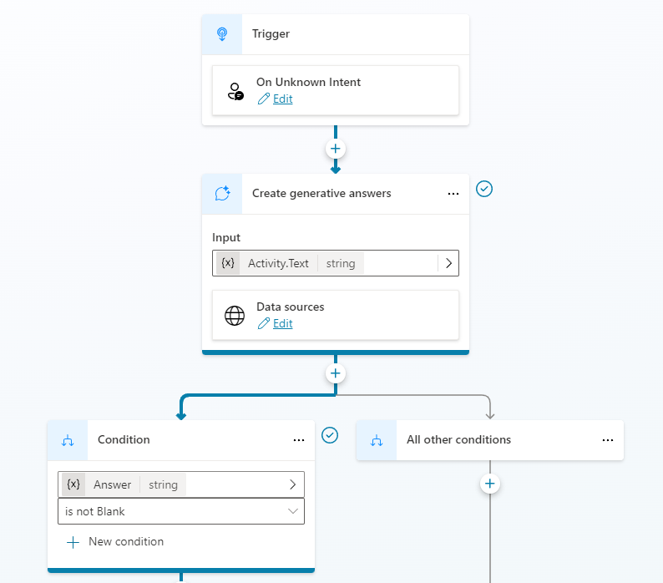

1. Review the **Create generative answers** node.

Task 1.3 - Enable knowledge

1. Select the **Overview** tab.
2. Verify that general knowledge is **Enabled**.

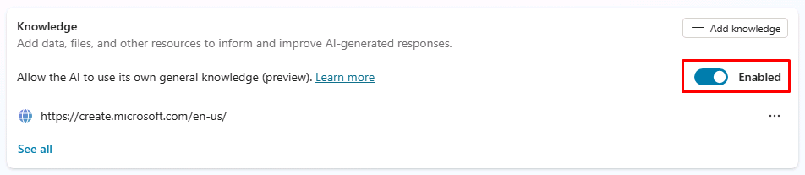

1. You should see the public website added as knowledge in a prior Lab.

Task 1.4 - Configure Authentication

1. Select **Settings** in the upper-right of the screen.
2. Select the **Security** tab.
3. Select the **Authentication** tile.
4. Select **Authenticate with Microsoft**.
5. Select **Save**.
6. Select **Save**.
7. Close the **Settings** menu by selecting the **X** in the upper-right of Copilot Studio.
8. Select **Publish** and select **Publish** again.

Exercise 2 - Add knowledge

Task 2.1 - Add knowledge from Dataverse

1. Select the **Knowledge** tab.
2. Select **+ Add knowledge**.
3. Select **Dataverse**.
4. Select the **Real Estate Property** table.

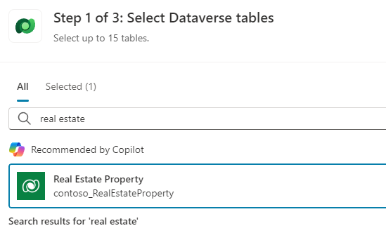

1. Select **Add**.

Task 2.2 - Add knowledge from files

1. Download this [**Microsoft case study**](https://download.microsoft.com/documents/customerevidence/Files/4000007499/SummitRealtyCaseStudy.docx) or [**SummitRealtyCaseStudy.docx**](https://raw.githubusercontent.com/MicrosoftLearning/mslearn-copilotstudio/refs/heads/main/Allfiles/SummitRealtyCaseStudy.docx) from GitHub.

ℹ️ **NOTE:** The link to the Microsoft case study is here: https://download.microsoft.com/documents/customerevidence/Files/4000007499/SummitRealtyCaseStudy.docx

1. Select **+ Add knowledge**.
2. Under **Upload file**, browse and select the case study that you downloaded.

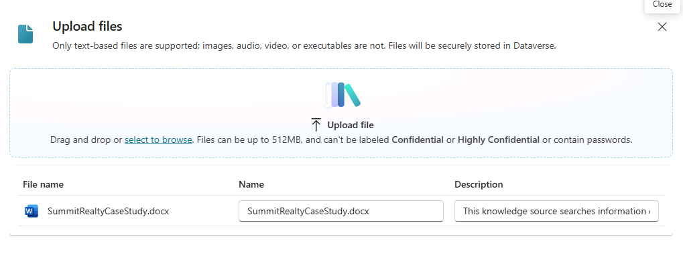

1. Select **Add**.

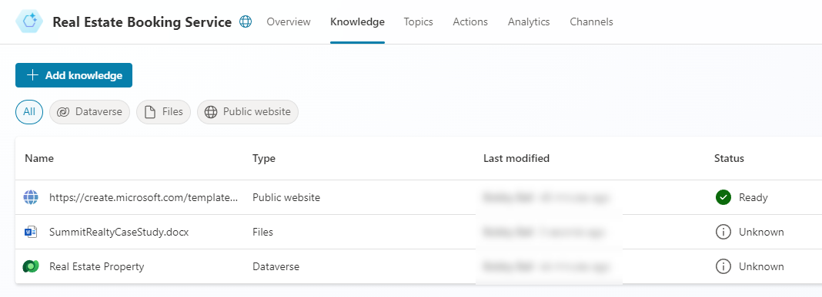

Exercise 3 - Configure Fallback topic

Task 3.1 - Use generative answers in System fallback topic

1. Select the **Topics** tab and select the **System** filter.
2. Select the **Fallback** topic.

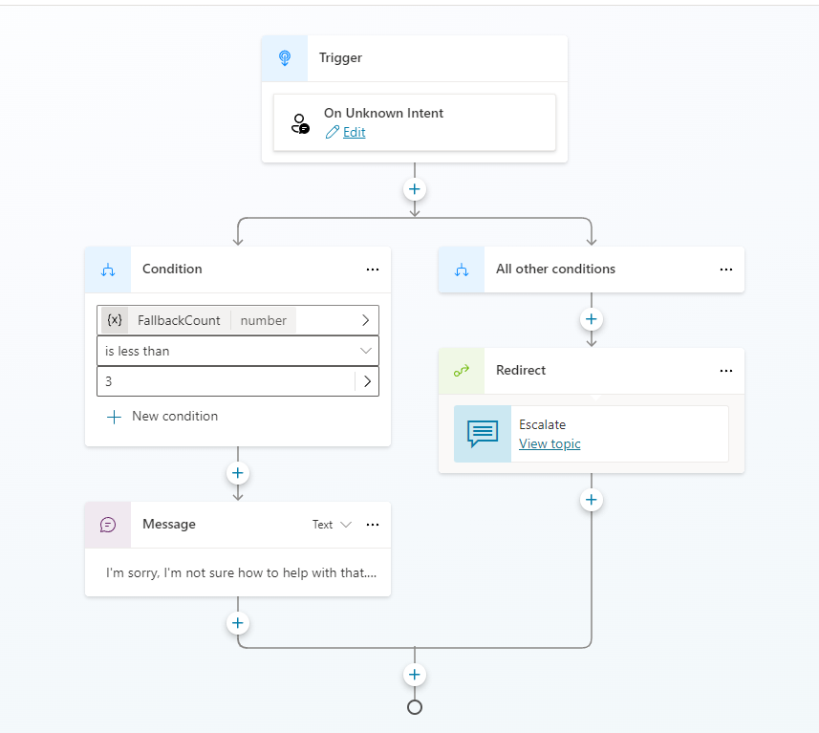

1. Select the **three dots** in the **Message** node and select **Delete**.
2. Select the the **+** icon under the **Condition** node, select **Advanced**, and select **Generative answers**.
3. Select **System** tab and select **Activity.Text** for the **Input** field.
4. Select **Edit** under **Data sources**.

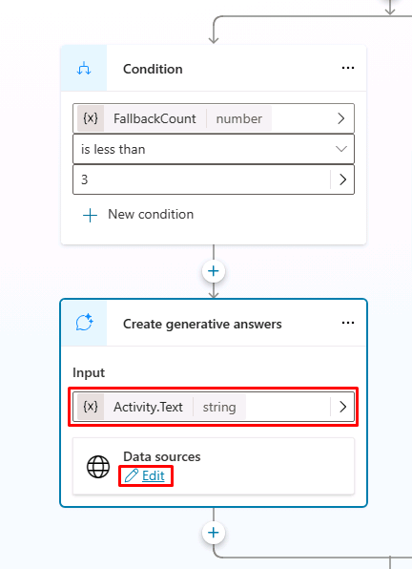

1. Select **Search only selected sources**.
2. Select the **Real Estate Property** Dataverse table.
3. Deselect **Allow the AI to use its own general knowledge**.
4. Select the **Customize** checkbox under **How strict should content moderation be?**, then select **Medium**.

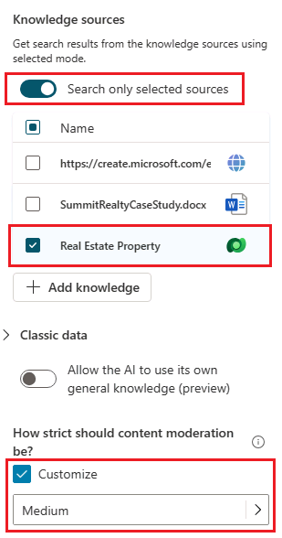

1. Select **Save**.

Exercise 4 - Test Generative AI

Task 4.1 Test the agent's knowledge

1. If it's not open, select the **Test** button in the upper-right of the screen to open the testing panel.
2. Select the **Conversation map** icon at the top of the testing panel in the upper-right of the screen.

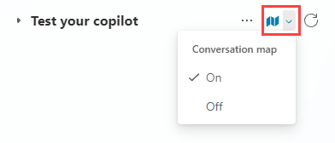

1. Select **On**.
2. Select the **Start a new conversation** icon at the top of the testing panel.
3. Explore the agent and see how it uses the knowledge sources.

Deploy agent to Microsoft Teams

Scenario

In this exercise, you will:

* Deploy an agent to the Microsoft Teams channel

This exercise will take approximately **10** minutes to complete.

What you will learn

* How to deploy an agent to Microsoft Teams

High-level lab steps

* Publish
* Deploy agent to Microsoft Teams

Prerequisites

* Must have completed **Lab: Use Generative AI in Microsoft Copilot Studio**

Detailed steps

Exercise 1 - Publish the agent

Task 1.1 - Publish the latest content

1. Navigate to the Microsoft Copilot Studio portal https://copilotstudio.microsoft.com and ensure you are in the appropriate environment.
2. Select **Agents** from the left navigation pane.
3. Select the agent you created in the earlier lab.
4. Select **Publish** and select **Publish** again.

**Note:** Publishing can take a few minutes.

Exercise 2 - Channels

With your agent published, you can make your agent available to users in Teams. This way you, your teammates, and your broader organization can interact with it.

Task 2.1 - Microsoft Teams channel

1. With your agent open in Microsoft Copilot Studio, select the **Channels** tab.
2. Select the **Teams and Microsoft 365 Copilot** tile.
3. Select **Add channel**.
4. Select **Availability options**.

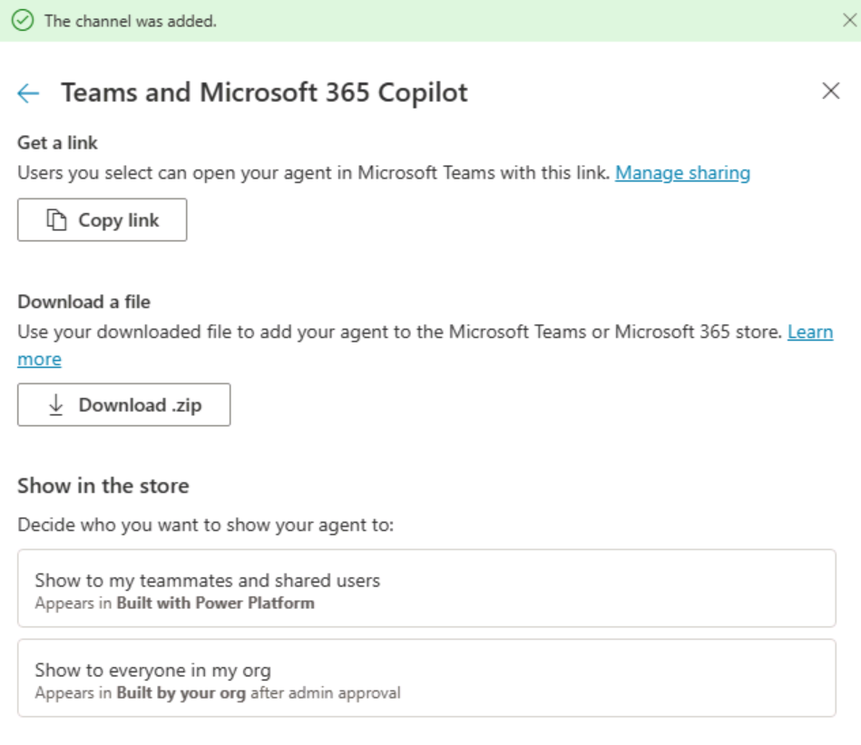

1. Select **Copy link**.
2. Select the back arrow in the top-left of the pane.
3. Select **See agent in Teams**
4. Select **Cancel** in the dialog box for **This site is trying to open Microsoft Teams**.
5. Select **Use the web app instead**.
6. Select **Add**.

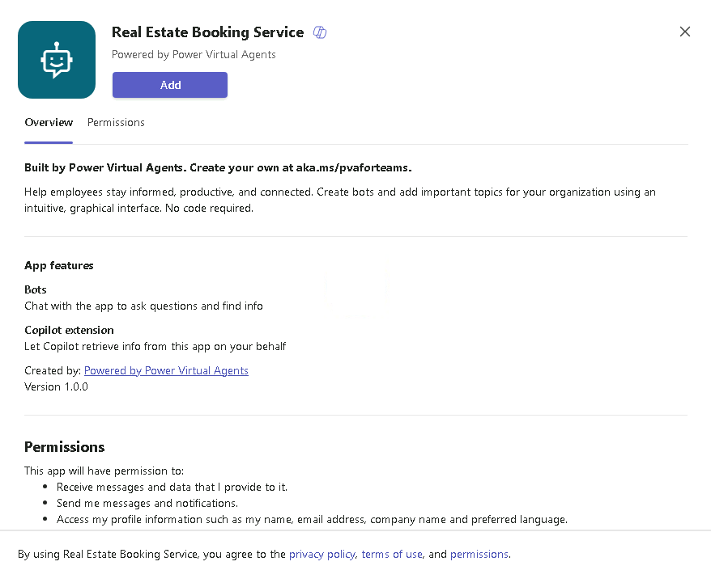

1. In the left-hand rail in Microsoft Teams, select the **ellipses (…)** to View more apps and search for **Real Estate**.
2. Select the **Real Estate Booking Service**.
3. Test the agent.

